Comparison of Durability of Calcium Aluminate and Sulphoaluminate Cements (CAC, CSA and HB-CSA) for Aggressive Environment

Binwal*, Bishwjeet, School of Chemical and Biomolecular Engineering, The University of Sydney, Australia; Valix, Marjorie, School of Chemical and Biomolecular Engineering, The University of Sydney, Australia

Keywords: CAC, CSA, HB-CSA, Acid resistance, Alkali-silica reactivity

ABSTRACT
Concrete made with traditional Portland cement in sewer environments is highly susceptible to microbiologically induced corrosion, which leads to deterioration of concrete infrastructure, reducing sewer pipe life and increasing maintenance and repair costs. This research addresses the challenge by evaluating the durability of three specialty binders: calcium aluminate cement (CAC), calcium sulphoaluminate cement (CSA), and high-belite calcium sulphoaluminate cement (HB-CSA). These materials were subjected to durability testing under conditions representative of aggressive sewer environments utilizing using laboratory-based methodologies. The findings were significant; in accelerated corrosion tests, CAC demonstrated superior performance compared to the other binders. The results indicate that CAC exhibits enhanced durability in acidic environments, significantly outperforming Portland cement systems. CAC forms a dense, alumina-rich matrix with hydration products that are more stable in acidic environments. In comparison, HB-CSA provides moderate acid resistance, and CSA was the least. In addition to accelerated corrosion testing, sorptivity, compressive strength, alkali-silica reactivity (ASR-AMBT), and water absorption were measured. Water absorption values for CAC and HB-CSA were approximately 5%, while CSA exhibited slightly higher values of around 7%. For sorptivity, all three binder systems recorded values within the <6 mm/√h range, indicating comparable transport properties. Strength development was evaluated at 1 and 28 days for both mortar and concrete specimens.

INTRODUCTION | BACKGROUND
Concrete produced with conventional Portland cement is susceptible to microbiologically induced corrosion (MIC) in sewer environments, where sulphur-oxidising bacteria generate sulphuric acid on concrete surfaces¹–³. This process causes progressive degradation of cementitious materials and reduces the service life of sewer infrastructure. Portland cement systems are particularly vulnerable because calcium-rich hydration products readily dissolve under acidic conditions, accelerating deterioration⁴. Specialty binders such as CAC and CSA have been proposed for aggressive environments due to their distinct hydration chemistry and potential durability advantages⁵–⁷. CAC forms alumina-rich hydrates that exhibit greater resistance to acidic dissolution, whereas CSA produces ettringite-based hydration products that influence both strength development and durability behaviour. CSA and its variants are also increasingly considered as low-carbon alternatives to Portland cement and are widely used in precast applications due to their rapid strength development. HB-CSA binders incorporate belite phases that generate C–S–H during hydration, which may improve matrix densification and durability performance. Despite their growing use in infrastructure applications, the resistance of CSA-based binders to aggressive sewer environments remains insufficiently understood. This study, therefore, evaluates the durability behaviour of CAC, CSA, and HB-CSA binders under conditions representative of corrosive sewer environments, providing a comparative assessment of their performance relative to conventional cement systems.

METHODS
Concrete and mortar specimens were prepared using CAC, CSA and HB-CSA binders, with ordinary Portland cement (OPC) used as a reference. Mixes were designed to achieve comparable workability and strength, allowing durability to be evaluated primarily as a function of binder chemistry. Durability was assessed using accelerated acidic exposure representative of sewer corrosion environments¹–³. Additional indicators included water absorption (AS 1012.21), sorptivity (ASTM C1585), compressive strength (AS 1012.9), and alkali–silica reactivity (AS 1141.60.1). Corrosion resistance was determined from the depth of degradation following acidic exposure, and results were interpreted across five sewer corrosivity classifications (C1–C5) representing increasing environmental severity.
KEY RESULTS AND CONCLUSIONS
The results show clear differences in fresh properties, strength development, and corrosion resistance between the binder systems. HB-CSA and CSA concretes set the fastest, reaching initial set in less than 30 minutes at w/c = 0.35, whereas CAC remained workable at this ratio. When the w/c ratio was reduced to 0.30, all binders set within 25–35 minutes. All binders achieved compressive strengths greater than 50 MPa at Day-28, with CAC exhibiting the highest strength (Figure 1). Water absorption values for CAC and HB-CSA were approximately 5%, while CSA showed slightly higher values (~7%). Sorptivity results indicated that HB-CSA had the lowest absorption behaviour (Figure 2), and none of the binders showed expansion with reactive sand. Acid exposure tests showed similar strength loss for CAC and CSA (55–58%) after 35 days, while HB-CSA exhibited lower strength loss (~41%). However, mass loss during acid exposure was lowest for CAC, followed by HB-CSA. Corrosion depth measurements provided the clearest indication of durability. CAC showed the lowest acid penetration (7.4 mm), followed by HB-CSA (10.5 mm), while CSA showed the greatest corrosion depth (20.5 mm), exceeding OPC (13.5 mm) (Figure 3). These differences are attributed to hydration chemistry and phase stability under acidic conditions. CAC forms alumina-rich hydrates that remain chemically stable in acidic environments, whereas CSA systems contain ettringite phases that dissolve under low-pH conditions, thereby increasing degradation²˒⁵. HB-CSA contains both ettringite and belite-derived C–S–H phases, resulting in intermediate durability. Overall, the results indicate that binder chemistry controls durability in aggressive sewer environments affected by microbiologically induced corrosion¹–³, with CAC showing the greatest resistance to acid corrosion.
Table 1. Comparison of water absorption for CAC, CSA, and HB-CSA concretes
Binders | Immersed Absorption; Ai (%) | Boiled Absorption; Ab (%)
CAC | 5.06 ± 0.02 | 5.43 ± 0.01
CSA | 7.19 ± 0.07 | 7.26 ± 0.07
HB-CSA | 5.75 ± 0.07 | 5.78 ± 0.07

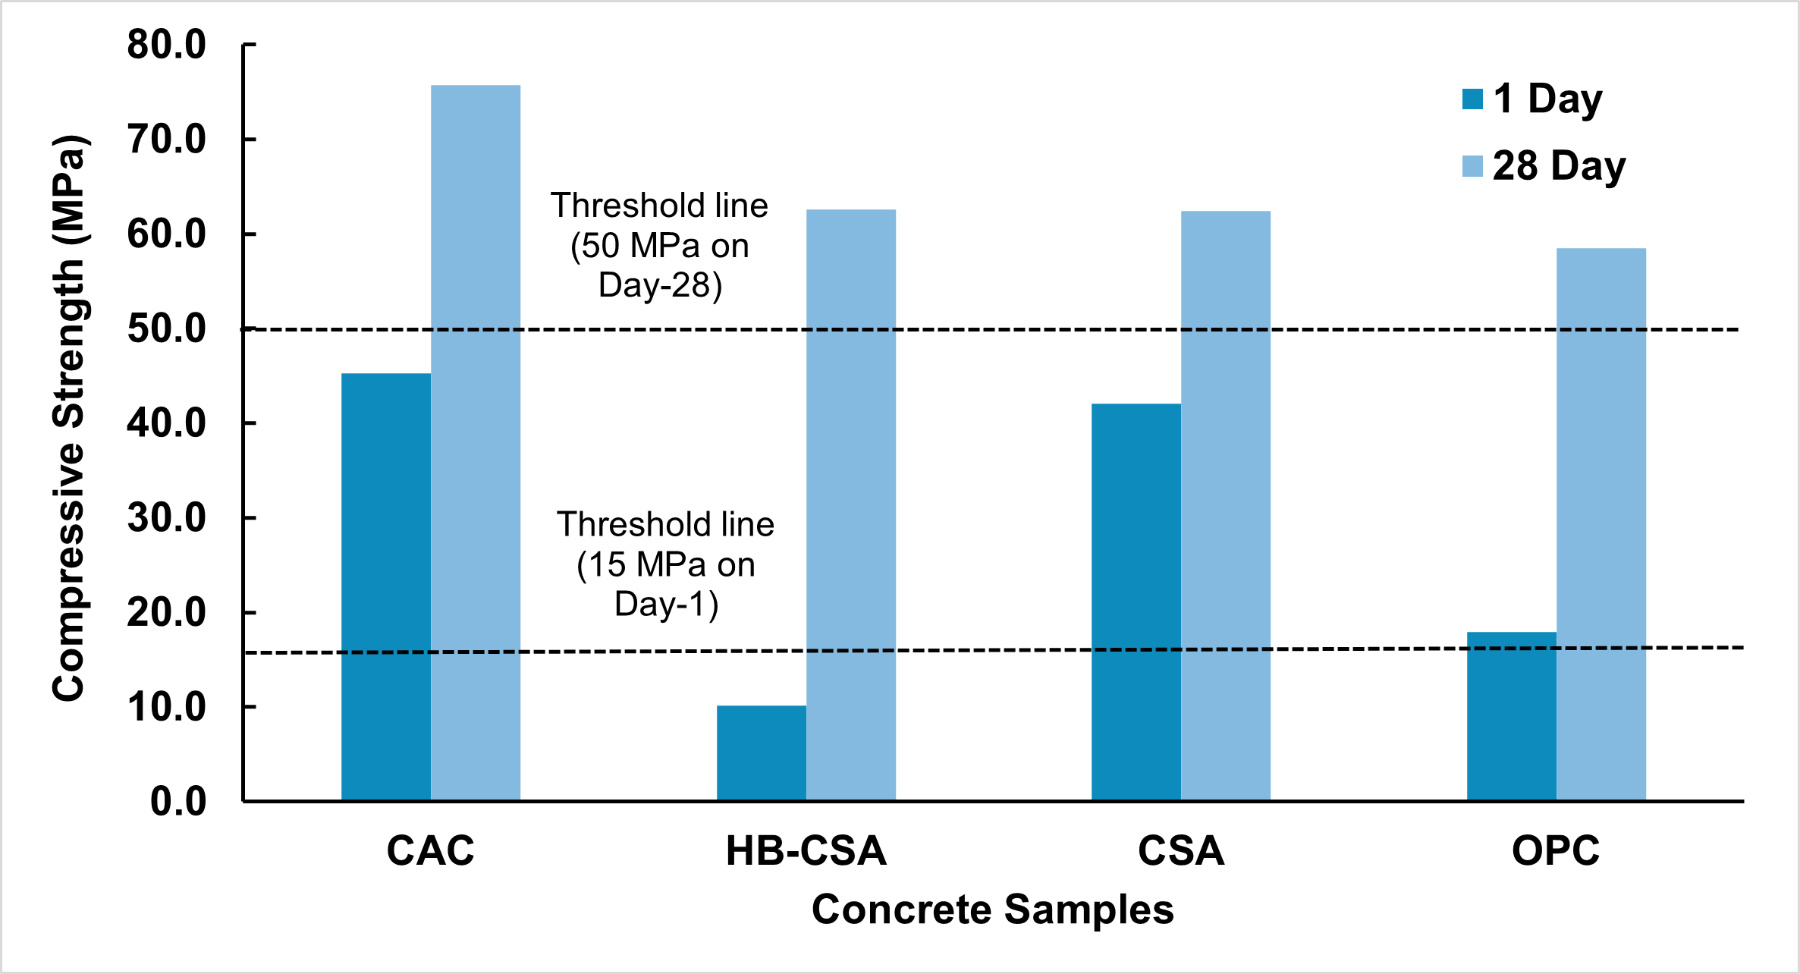
Figure 1. Strength comparison of CAC, CSA and HB-CSA with OPC at Day-1 and Day-28
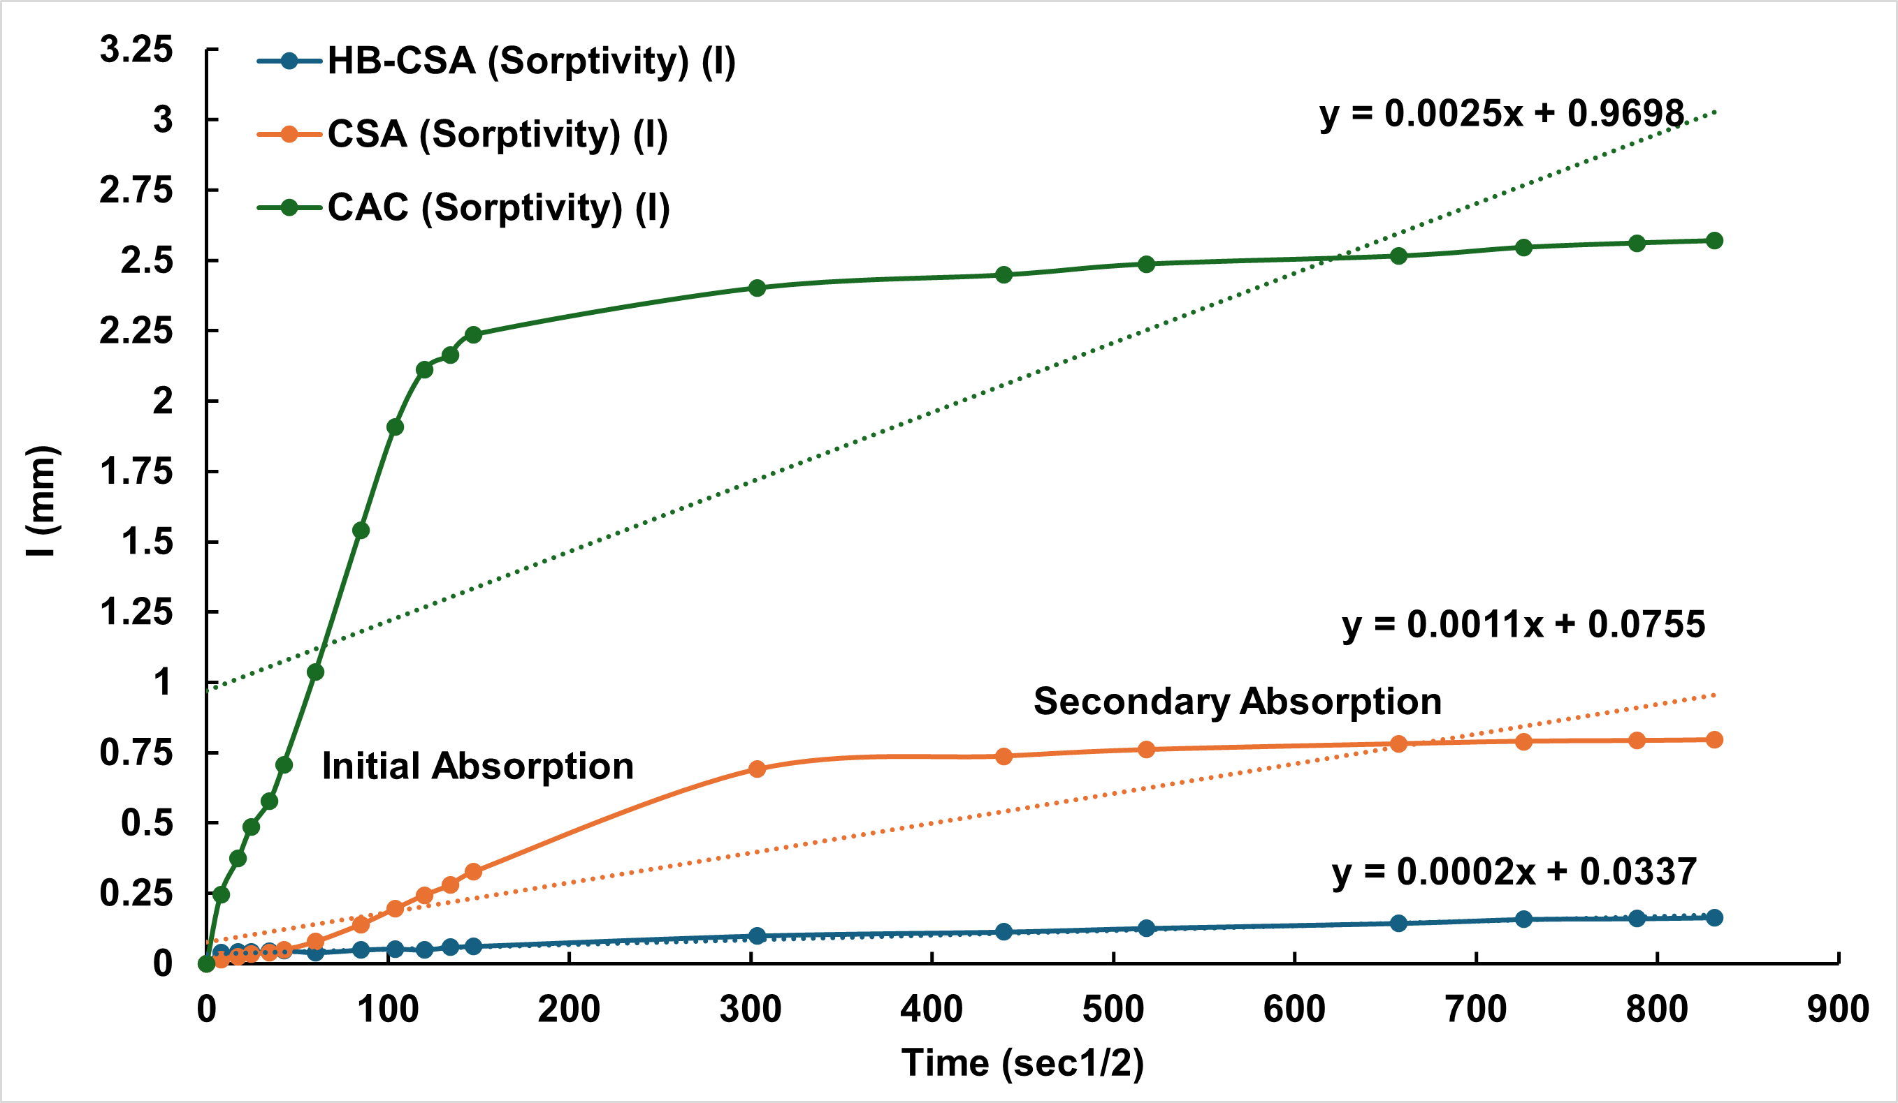
Figure 2. Initial and secondary absorption of CAC, CSA and HB-CSA

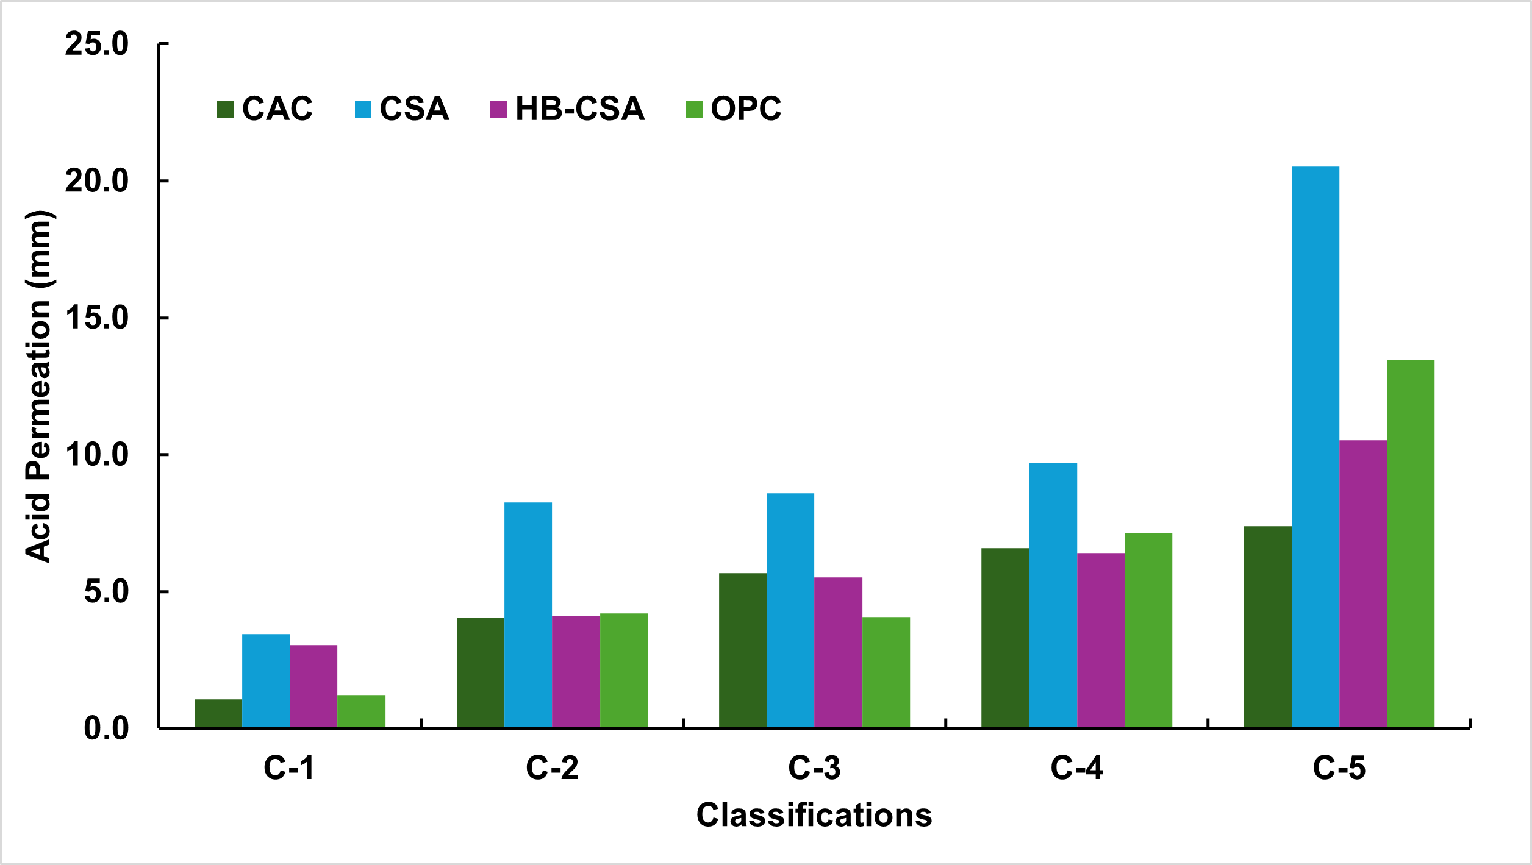
Figure 3. Corrosion depth of CAC, CSA, HB-CSA, and OPC across corrosivity classes C1–C5

future research

The experimental program forms part of a broader thesis framework in which CAC, CSA, and HB-CSA were evaluated using standardised tests to establish a baseline for fresh, mechanical, and durability performance. Future work will apply the same testing matrix to emerging low-carbon binders and compare their performance directly with these reference systems under identical conditions.

REFERENCES
[1] S.K. Pramanik, M. Bhuiyan, D. Robert, R. Roychand, L. Gao, I. Cole, B.K. Pramanik, Bio-corrosion in concrete sewer systems: Mechanisms and mitigation strategies, Science of The Total Environment 921 (2024) 171231. https://doi.org/10.1016/j.scitotenv.2024.171231.
[2] C. Grengg, F. Mittermayr, N. Ukrainczyk, G. Koraimann, S. Kienesberger, M. Dietzel, Advances in concrete materials for sewer systems affected by microbial-induced concrete corrosion: A review, Water Res. 134 (2018) 341–352. https://doi.org/10.1016/j.watres.2018.01.043.
[3] M.W. Kiliswa, K.L. Scrivener, M.G. Alexander, The corrosion rate and microstructure of Portland cement and calcium aluminate cement-based concrete mixtures in outfall sewers: A comparative study, Cem. Concr. Res. 124 (2019). https://doi.org/10.1016/j.cemconres.2019.105818.
[4] H.A. Khan, A. Castel, M.S.H. Khan, A.H. Mahmood, Durability of calcium aluminate and sulphate resistant Portland cement based mortars in aggressive sewer environment and sulphuric acid, Cem. Concr. Res. 124 (2019). https://doi.org/10.1016/j.cemconres.2019.105852.
[5] A.T. Bakera, A. Aboulela, M.G. Alexander, A. Bertron, M. Peyre Lavigne, S. Meulenyzer, C. Patapy, Performance of Sewer Concretes with Calcium Sulpho-Aluminate Cement and Portland Cement Blends: Field and Laboratory Studies, Materials (Basel). 18 (2025). https://doi.org/10.3390/ma18061256.
[6] P. Sturm, G.J.G. Gluth, C. Jäger, H.J.H. Brouwers, H.C. Kühne, Sulfuric acid resistance of one-part alkali-activated mortars, Cem. Concr. Res. 109 (2018) 54–63. https://doi.org/10.1016/j.cemconres.2018.04.009.
[7] H.A. Khan, M.S.H. Khan, A. Castel, J. Sunarho, Deterioration of alkali-activated mortars exposed to natural aggressive sewer environment, Constr. Build. Mater. 186 (2018) 577–597. https://doi.org/10.1016/j.conbuildmat.2018.07.137.

