Fast and stable: Calcium aluminate cements as accelerators in highly heat-insulating mineral foams

Laub, Klemens¹, Höchst, Attila², GerlicherTobias², Tatarin, René², Landmann, Mirko², Fetter, Robert²

¹Weimar Institute of Applied Construction Research (IAB), Über der Nonnenwiese 1, 99428 Weimar, Germany, k.laub@iab-weimar.de, ²Weimar Institute of Applied Construction Research (IAB), Über der Nonnenwiese 1, 99428 Weimar, Germany

Keywords: mineral foam, insulation, acceleration of cement hydration, setting behaviour, rheology, material testing and properties

ABSTRACT
In recent years, the increasing requirements for thermal insulation in building construction and society's growing environmental awareness have led to the increased development of highly thermally insulating, recyclable cement-based mineral foams with low thermal conductivities (λ_{10°C, dry} ≤ 0,035 W/(m·K)) and low dry densities (ρ ≤ 70 kg/m³). Their production and application are associated with several challenges. One of the main ones is the stabilization of the pore structure through early and rapid structure formation, which can be solved by using CAC as an accelerator system.
Through extensive research and development work in cooperation with its partners, the IAB investigated different rapid binder systems with different combinations of ordinary Portland cements (OPC) and calcium aluminate cements (CAC). It was found that laboratory tests are already sufficient to estimate and monitor the foam stability and setting behaviour of industrially produced mineral foams. First and foremost, rheometric measurements to characterise the setting behaviour of the binder slurries and the mineral foams should be mentioned here.
The knowledge gained contributes both to resource efficiency in mineral foam production and to the wider application of this technology, which has the potential to sustainably increase the energy efficiency of buildings.

INTRODUCTION | BACKGROUND
The IAB has developed a patented manufacturing process for mineral foam in which two mineral foams are continuously and controllably mixed [1]. While the binder of one mineral foam can be an OPC, the second mineral foam is based on a CAC. By combining the two mineral foams in a targeted manner, the start of the structure formation can also be adjusted during the manufacturing process depending on the building materials to be filled and the ambient conditions. The user of this process is free to select the raw materials independently, but this requires specific expertise and suitable methods.
Therefore, specific requirements must be defined, above all a processing window for the begin of the setting under real production conditions. Figure 1 shows the overall specifications for the filling of bricks with accelerated mineral foam.

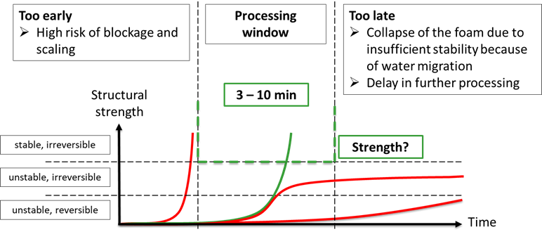
Figure 1. Processing window for accelerated mineral foam for filling bricks
During the industrial production and filling several more challenges must be considered, which are specific to mineral foam. If these challenges, as shown in Table 1, are not taken into account, problems such as the following may arise: Large bubbles, cracks or collapsing.

Table 1. Challenges for mineral foam during industrial production
Water migration/drainage | In-process handling | Coalescence/Ostwald-ripening
- Suction of porous materials  - Drainage caused by gravity | - Movement  - Shocks/bumps  - Lifting | - Thermodynamically driven spontaneous processes

In order to ensure the high quality of the manufactured products, the raw materials must be tested for usability in advance and during production. The focus here is on the used binders (OPC/CAC).

METHODS
Characterising the setting behaviour is the key. The Viskomat NT was chosen as the preferred method to measure on the slurries of the which the mineral foam is produced. Rheometric measurements using a VANE geometry at very low speeds allowed the increase in torque and shear stress to be observed. This measurement method is hereinafter referred as ‘shear test’ and was chosen due to the following constraints: very high water/solid ratios (1.5 - 2.0) of the slurries, high temporal resolution and sensitivity of the measurements during setting within 15 minutes, temperature insensitivity of the measuring equipment and the possibility of using the determined shear stresses in the physical unit Pascal for modelling. In addition, it is possible to transfer the results of the slurries to those of the mineral foams, which can be characterised rheometric using the same or similar equipment in future.

Key findings
To determine whether the shear test is a suitable tool for predicting the setting behaviour of mineral foams, various combinations of OPC and CAC were investigated. The challenges here were, on the one hand, to test at comparable temperatures and, on the other hand, to determine the begin of the setting of the mineral foams. This was done manually and was therefore subjective and inaccurate. To test the practical suitability of the mineral foams produced using a foam generator, several vertically perforated bricks were filled.
One general finding is, that all tested CAC slurries were foamable, which is a essential requirement for the foam generator tests.
In order to examine the various combinations, the same basic recipe consisting of binder, filler, water, foaming agent and hydrophobic agent was used, with only the binders being replaced 1:1 in mass. The ratio OPC/CAC = 3.7 and the temperature of the slurries was between 25 °C and 26 °C, which was in the range of the produced foams. Table 1 shows three examples of combinations of different OPCs and CACs, which were tested with the shear test and the foam generator.

Table 2. Comparison of the shear test and foam generator test of three different combinations of OPC and CAC
Example 1  OPC1 + CAC1 | Example 2  OPC1 + CAC2 | Example 3  OPC2 + CAC1
Shear test
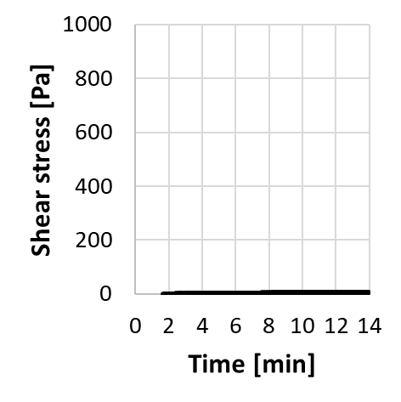  time@10Pa: N/A | 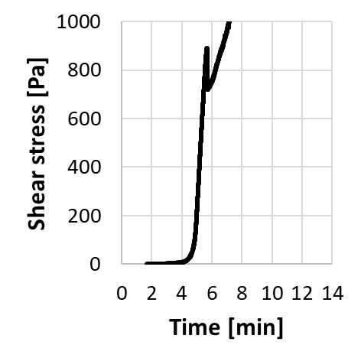  time@10Pa: 4.14 min | 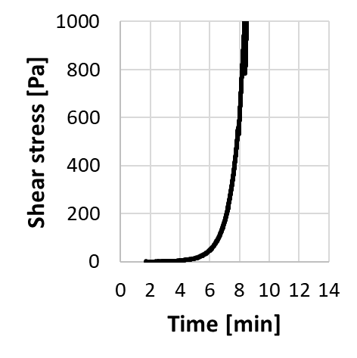  time@10Pa: 4.72 min
Foam generator test
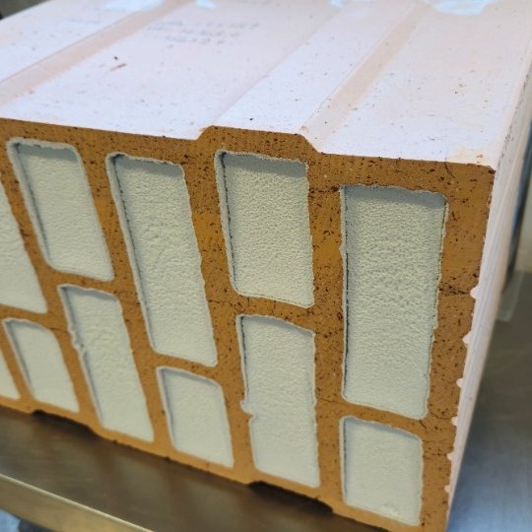  No begin of setting could be detected. Due to slight collapse of foam, no ρ_{dry} and λ_{10°C, dry} were tested. | 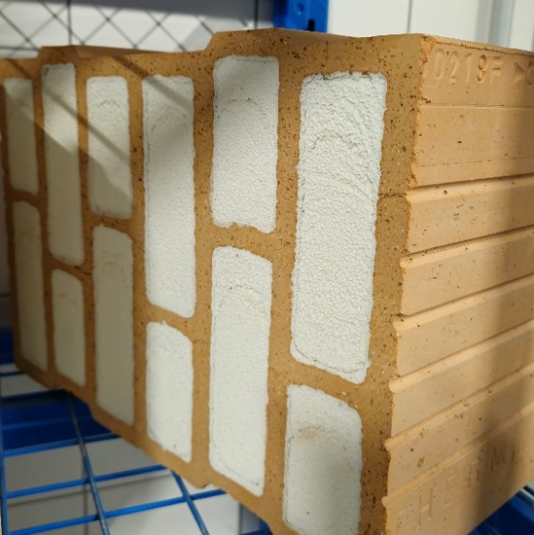  Begin of setting: 6.5 min  ρ_{fresh} = 122 kg/m³  ρ_{dry} = 61 kg/m³  λ_{10°C, dry} = 34.1 mW/(m·K) | 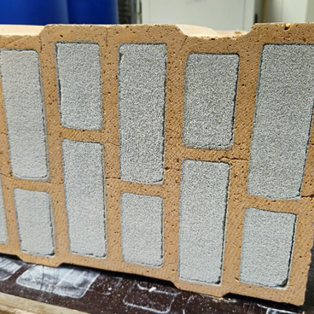  Begin of setting: 5.5 min  ρ_{fresh} = 115 kg/m³  ρ_{dry} = 52 kg/m³  λ_{10°C, dry} = 35.1 mW/(m·K)
The results shown here indicate that it is possible to distinguish between setting and non-setting combinations. However, due to the inadequacy of manual testing, it is currently difficult to make accurate predictions based on the shear test regarding the setting behaviour of mineral foam itself. Results are currently available for eight different CACs that were combined with different OPCs, which show, that the shear test is a suitable screening method. The results also show that CACs can work different depending on the used OPCs. The differences consist of whether structure formation takes place at all in the intended processing window, when setting begins and how quickly it progresses. In special cases, a plateau may form, i.e. early setting can be detected, but then the setting process stops, so that no further structure formation takes place. This scenario poses a particular challenge with the testing methods currently available in foam production: Setting can be detected manually, but the structure strength that has been built up and remains is not sufficient to prevent the mineral foam from collapsing as a result of progressive water migration.

future research needs
The construction industry's demand for a higher degree of automation is raising new questions regarding mineral foam application in terms of material optimisation and adaptation, measurement technology options (inline/offline) and process engineering implementation. This extended abstract emphasises that clarification of the differences between the setting behaviour of suspensions (shear test) and the foams produced from them is a pressing issue. Furthermore, measurement methods need to be developed to characterise the setting behaviour of mineral foams. At the same time, the process engineering development of large-scale solutions for the automated production and filling of mineral foam must be carried out.

CONCLUSIONS
Fundamental knowledge was gained about the rapid binder system in terms of methodology, cement chemistry and measurement technology. As part of research projects [2,3], a measuring method was developed that enables the characterisation of the setting behaviour of the rapid binder system in a quick and uncomplicated way. The developed shear test offers a range of further options for analysing rapidly setting binder systems. The patented manufacturing process and mineral foam formulations developed for this purpose based on CAC offer a wide range of applications. First and foremost, among these is the filling of ceramic and cementitious wall building materials. Another area of application is the precast concrete industry.

REFERENCES
[1] EP 3 156 383 B1: Method for producing an inorganic foam., Inventor: Höchst, A., Applicant: IAB - Institute of Applied Construction Research gGmbH, 2017
[2] K. Laub, A. Höchst, Entwicklung von klinker- und CO2-effizienten Schnellbindersystemen zur Herstellung von schnellerhärtenden Mineralschäumen und Anwendung in der Fertigteiltechnologie, Projektabschlussbericht, BMWK-Programm INNO-KOM, Fdg. 49VF210029, IAB Weimar gGmbH, 2024.
[3] K. Laub, A. Höchst, Entwicklung von Qualitätsmessverfahren zur Inline-Bestimmung der Mineralschaumeigenschaften während der Produktion, Projektabschlussbericht, BMWK-Programm INNO-KOM, Fdg. 49MF220234, IAB Weimar gGmbH, 2025.

