Calcium Aluminate Cements in Context: Durability Mechanisms and Transport-Controlled Performance For Conventional Concrete Applications

Kurtis*, Kimberly E., Georgia Institute of Technology, Atlanta, Georgia USA
Alapati, Prasanth, Furno Materials, South San Francisco, California, USA
Burris, Lisa, The Ohio State University, Columbus, Ohio, USA
Ley, M.Tyler, Oklahoma State University, Stillwater, Oklahoma, USA
Peery, J., Oklahoma Dept. of Transportation,Oklahoma City, Oklahoma, USA
Hajibabaee, Amir, Ozinga, Chicago, Illinois, USA
Behravan, Amir, Virginia Dept of Transportation, Richmond, Virginia, USA
Khanzadeh Moradllo, Mehdi, Temple University, Philadelphia, Pennsylvania, USA
Berke, N., Tourney Consulting Group, Kalamazoo, Michigan, USA
Moser, Robert, U.S. Army Engineer Research and Development Center (ERDC), Vicksburg, Mississippi, USA

Keywords: durability, alkali-silica reaction, corrosion, carbonation, CAC, CAC blends

ABSTRACT
Calcium aluminate cements (CACs) are often treated as specialty binders, but recent work suggests their performance merits broader consideration. Here, the performance of CAC and CAC blends is evaluated in the context of other alternative cementitious materials (ACMs) - including calcium sulfoaluminate (CSA) cements, alkali-activated binders, magnesium phosphate cements, and blended systems - and benchmarked against ordinary portland cement (OPC). The work emphasizes durability-critical behaviors relevant to transportation and other infrastructure applications, including resistance to chemical sulfate attack, alkali–silica reaction (ASR), and transport-controlled deterioration. Microstructural characterization is used to interpret observed durability trends and to clarify the roles of hydration and conversion products, pore solution composition, and pore connectivity. While CACs are well known for rapid strength development and sulfate resistance, results drawn from a broader experimental dataset demonstrate that well-designed CAC systems can also exhibit favorable resistance to ASR expansion and chloride ion penetration relative to OPC. At the same time, the findings reinforce that no single binder system is universally optimal. Instead, this study identifies application contexts in which CACs and other ACMs may offer meaningful durability advantages in conventional concrete construction.

INTRODUCTION

Growing interest in alternative cementitious materials is driven by both sustainability objectives and the need for improved durability in aggressive service environments. Calcium aluminate cements occupy a unique position within this landscape: they are commercially mature, well understood in specialty applications, yet rarely considered for conventional reinforced concrete construction.

A recently published US Federal Highway Administration report¹ evaluated and compared the performance of CACs and other ACMs to PC, examining mechanical behavior, dimensional stability and durability. This extended abstract presents previously unpublished long-term durability data, together with transport-based and microstructural interpretations that enable more confident differentiation of CAC, CAC blend, and other ACM performance relative to OPC. The focus here is durability-relevant findings most pertinent to infrastructure applications, including sulfate resistance, ASR mitigation, and transport-controlled deterioration mechanisms.

METHODS
Tested systems included an ASTM C150 Type I/II OPC, and multiple compositions of CAC, CSA, and magnesium phosphate cements, and alkali-activated binders. Cement compositions and concrete mixture designs have been previously reported¹⁻². Durability-focused testing included:
- Chemical sulfate resistance, using standard testing (ASTM C1012), and constant-pH sulfate exposure coupled with strength retention and microstructural analysis;
- ASR assessment, incorporating both accelerated tests (ASTM C1260) and long-term concrete prism tests (ASTM C1293) extending to two years;
- Transport characterization, including formation factor (F), sorptivity, and resistivity-based indicators of pore connectivity, as well as direct measures of chloride migration;
- Microstructural analysis, including OM, SEM, and TGA used to interpret hydration products, bound water evolution, and phase stability.
Mixture designs emphasized compatibility with conventional batching and placement practices, allowing durability trends to be interpreted in a construction-relevant context.

Key findings and DISCUSSION
For brevity, only results showing resistance to constant-pH sulfate attack, ASR (via two-year concrete prism testing), and transport are included.

Sulfate Resistance
Changes in compressive strength during accelerated sulfate exposure at constant pH (Fig. 1) reveals that sulfate resistance in ACMs is governed not simply by bulk composition, but by the formation and chemistry of near-surface reaction layers and the permeability of the underlying matrix. Ettringite-based systems, including CSA cements and CAC blends (CACT), develop a dense, aluminum-rich (C,N)-A-S-H “armoring” layer that limits sulfate ingress, suppresses internal damage, and promotes retention of compressive strength. In contrast, converted CAC systems exhibit rapid degradation due primarily to increased porosity associated with conversion, which facilitates sulfate transport and extensive ettringite formation throughout the matrix. Together, these findings demonstrate that sulfate sulfate in ACMs depends critically on coupled phase chemistry, microstructural evolution, and transport phenomena, rather than on sulfate exposure alone.

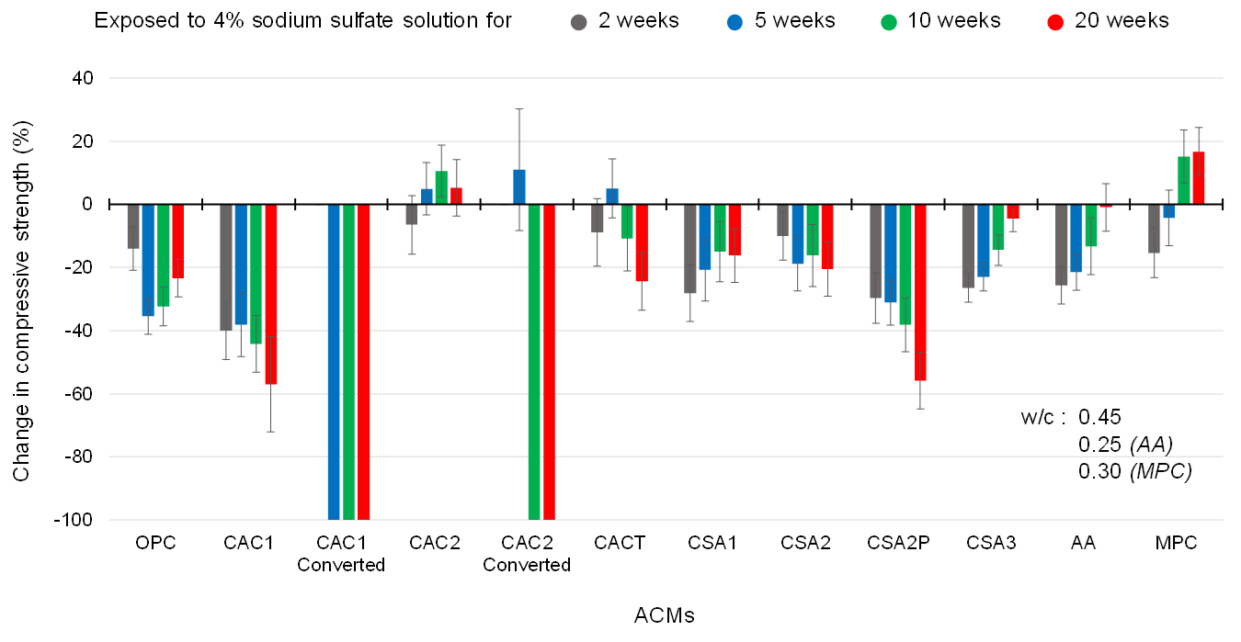
Figure 1. Average change in compressive strength, relative to strength prior to the exposure, for OPC and ACM paste cubes, exposed to a 4% (w/w) sodium sulfate solution. A 100% strength loss indicates the sample integrity was so compromised it could not be tested.

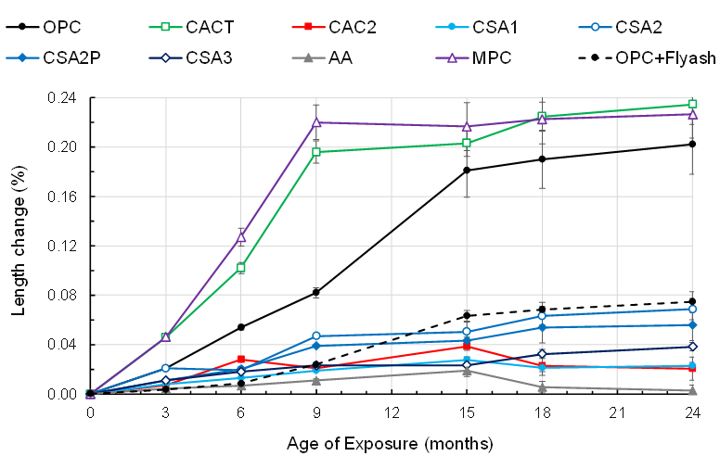
Figure 2. Comparison of expansion of ASTM C1293 concrete prisms prepared with different ACMs, compare with OPC and OPC with 50% Class C fly ash at 2 years.
Alkali–Silica Reaction Mitigation
Two-year concrete prism test data (Fig. 2) demonstrates that CAC concrete experienced less expansion relative to OPC when tested with a reactive aggregate. These findings are consistent with the lower pore solution alkalinity and alkali availability in CAC compared to OPC. However, a blended CAC (i.e., CACT) experienced higher expansion than OPC, attributable to increased pore connectivity combined with sufficient alkali availability from the OPC component.

Transport Properties
As shown in Fig. 3, CAC and CACT mortars generally exhibit lower formation factors than OPC at comparable total porosity (φ), indicating a more transport-efficient pore network despite similar void fractions. This trend is consistent with paste sorptivity performed at varying w/b, which show higher total water sorption in CAC and CACT at similar w/b compared to OPC. Of the ACMs examined, sorptivity in CACT also showed the greatest sensitivity to variations in w/b. These results demonstrate that total porosity alone is insufficient to assess durability, and that transport metrics capturing pore connectivity and tortuosity are required.
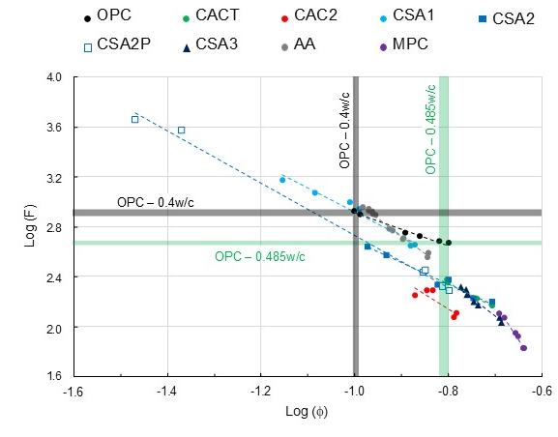
Figure 3. Formation factor (F) versus total porosity (𝛷) in ACM mortar mixtures compared to that of OPC at varied water-to-binder ratios (w/b).

REFERENCES
- Kurtis, K.E., Alapati, P., Burris, L.E., Ley, M.T., Peery, J., Hajibabaee, A., Behravan, A., Khanzadeh, M., Berke, N.S., Moser, R., Novel Alternative Cementitious Materials for Development of the Next Generation of Sustainable Transportation Infrastructure, FHWA-HRT-24-012, Federal Highway Administration, Turner-Fairbank Highway Research Center, Washington, DC, 2024. https://doi.org/10.21949/1521792
- Alapati, P., Multiscale Investigation of Alternative Cementitious Material Systems, Ph.D. Thesis, Georgia Institute of Technology, Atlanta, GA, 2020.

