Ultra-Rapid Hardening Repair Mortar with Amorphous Calcium Aluminates for Freezer Floor Applications at –25 ℃

Katagiri*, Tomoki, MU MATEX Co., Ltd., Ube-City, Japan;
Nishimura, Kouichi, MU MATEX Co., Ltd., Ube-City, Japan;
Kimoto, Daisuke, MU MATEX Co., Ltd., Ube-City, Japan;
Nukita, Makoto, MU MATEX Co., Ltd., Ube-City, Japan

Keywords: amorphous calcium aluminates, ultra-rapid hardening, freezer repair, self-leveling underlayment, cold temperature mortar

ABSTRACT
Repairing damaged flooring in commercial freezer warehouses presents significant challenges due to the extremely low temperatures, often below –25 ℃, where continuous forklift traffic and localized freeze–thaw actions near the entrance area accelerate surface deterioration. This study describes the development of a self-leveling, ultra-rapid-hardening mortar designed specifically for subzero applications. The binder system is based on amorphous calcium aluminates (ACA), which exhibit high reactivity and excellent early-age performance in low-temperature environments. The formulation was optimized to ensure adequate flowability and high early strength without the need for external substrate heating.
Laboratory tests evaluated hydration kinetics, setting time, and mechanical properties of the mortar at –25 ℃. Results demonstrated that the ACA-based system achieved the initial set within 10 minutes and compressive strength exceeding 30 MPa after 3 h, even under freezing conditions. The product was successfully applied in a real-world industrial freezer setting, confirming its practical applicability.
This paper highlights the potential of ACA as a next-generation binder for cold-environment infrastructure repair and contributes to expanding the scope of high-performance calcium aluminate-based materials.

INTRODUCTION
At −25 °C, freezer warehouse floor repair is typically challenging. This is due to the constraints of continuous operation, and conventional mortars fail because of immediate freezing, resulting in strength from ice rather than hydration ^{[1]}. Organic-based materials are unsuitable in food environments due to food safety compliance. Amorphous calcium aluminates (ACA) offer a promising alternative, as their rapid dissolution and highly exothermic hydration enable reaction even under subzero conditions ^{[2–4]}. This study develops and evaluates an ultra-rapid-hardening ACA-based mortar for freezer floor repair and compares its performance with that of a ternary system composed of calcium aluminate cement (CAC), ordinary Portland cement (OPC), and anhydrite.

METHODS

Materials
Two repair mortar systems were evaluated under subzero conditions:

ACA-based system
The ACA-based system consists of the following: anhydrite blended with ACA, lithium carbonate, polycarboxylate ether (PCE) superplasticizer, retarder (oxycarboxylic acid), redispersible polymer powder, and defoamer. The dry mix had a binder content of 60 wt% and a water-to-powder ratio of 20.0%.

Ternary system (as a reference fast-setting mortar)
The ternary consists of crystalline CAC + anhydrite + rapid OPC, lithium carbonate, PCE superplasticizer, retarder (oxycarboxylic acid), redispersible polymer powder, and defoamer. The dry mix had a binder content of 61 wt% and a water-to-powder ratio of 18.8 wt%.

Aggregates consisted of standard oven-dry silica sand. The water used was tap water.

Mix design & batching
Powder components were preconditioned at 10 °C. Mixing water was preheated to 30 °C. Slurries were mixed at a temperature of ~10 °C.

Compressive strength
Compressive strength was measured at −25 °C after 1 h, 3 h, 7 days, and 28 days (φ50 × 100 mm cylinders; demolding at each curing time).

Substrate and environment
All specimens were cast on frozen concrete paving slabs (300 × 300 × 60 mm) and stored at −25 °C.

Temperature profiling of slurry
Thermocouples were installed on a concrete pavement slab at the center (casting point), mid-span (~75 mm), and edge (~113 mm) to capture lateral gradients. Additional thermocouples were embedded at depths corresponding to the surface (~2 mm), mid-depth (~12 mm), and bottom (~25 mm).

Field simulation
A refrigerated truck maintained at −25 °C was used for pouring and troweling, covering an area of approximately 1200 mm × 1800 mm with a 25 mm thick mortar layer.

KEY FINDINGS AND CONCLUSIONS
Figure 1 compares the compressive strength development of the ACA-based mortar and the ternary rapid system under −25 °C. The ACA system achieved an initial set within approximately 10 min and exceeded 30 MPa after 3 h, thereby meeting trafficability requirements for freezer warehouses. In contrast, the ternary system exhibited almost no setting at an early age, reaching only approximately 0.9 MPa after 1 h. The subsequent strength increase was largely attributed to freezing rather than hydration, with the strength reaching only approximately 25 MPa even after 28 days.
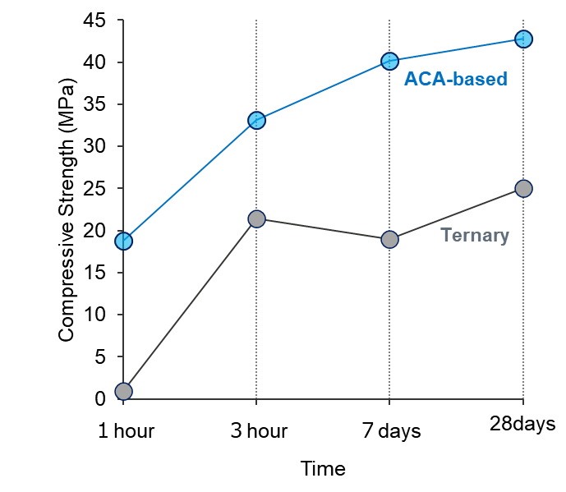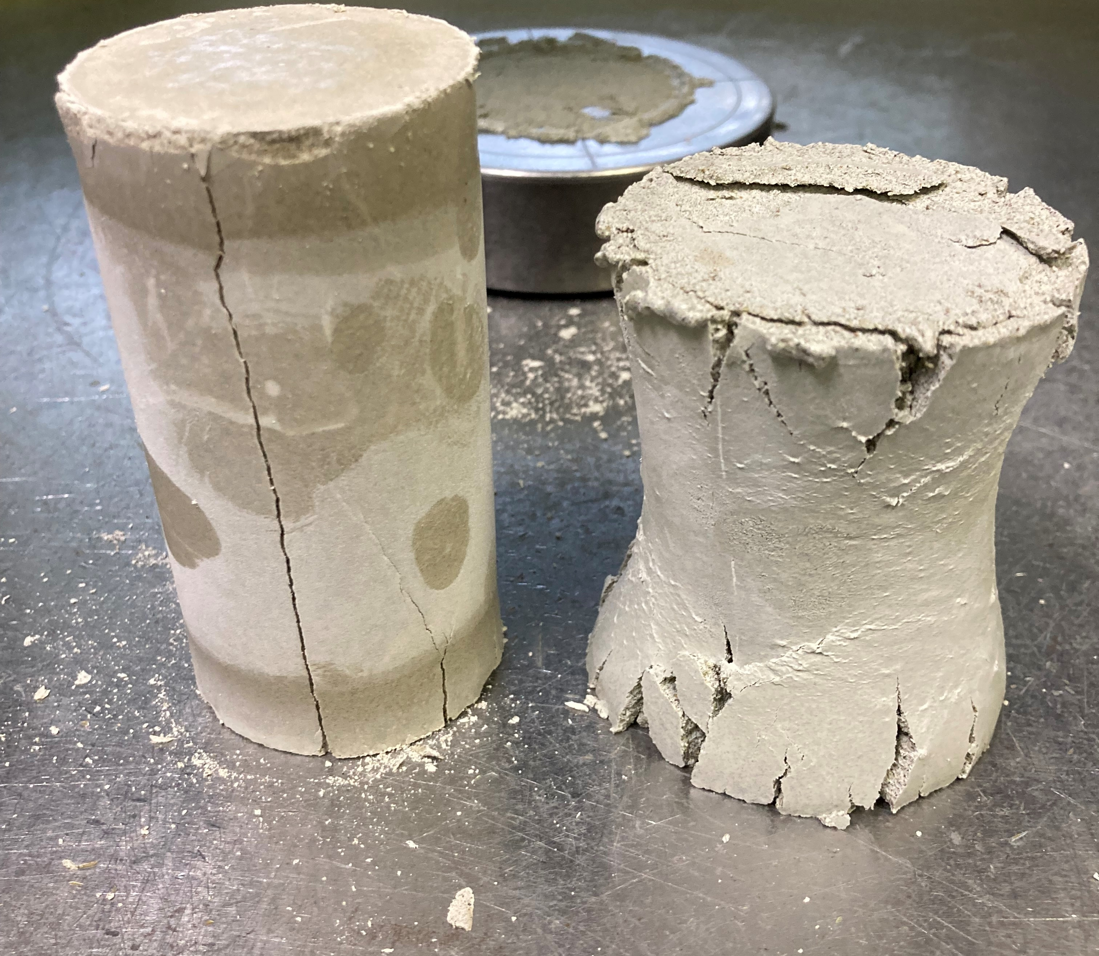
Figure 1. Compressive strength development at −25 °C for ACA-based and ternary systems (graph), with corresponding failure modes after testing: hydrated ACA mortar (left) and frozen conventional mortar (right).

Figure 2 illustrates the temperature evolution of the mortar at −25 °C. The left panel captures lateral (in‑plane) gradients from the casting point to the edge, whereas the right panel captures vertical (through‑thickness) profiles at three depths. Hydration heat originated at the center surface and propagated both depth-wise and laterally, sustaining reactions in the colder bottom and edge regions of the substrate.
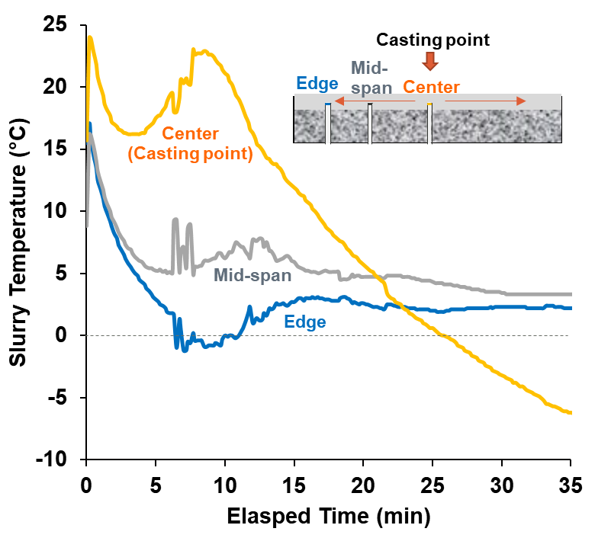 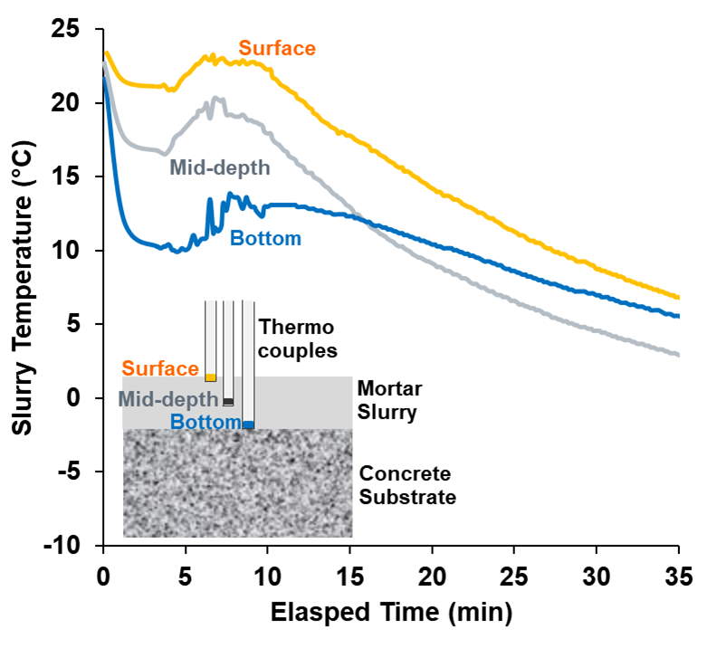
Figure 2. Temperature evolution at −25 °C: lateral gradients (left) and depth profiles (right). Lateral gradients at center (casting point), mid-span (~75 mm), and edge (~113 mm); depth profiles at surface (~2 mm), mid-depth (~12 mm), and bottom (~25 mm).

Field application trials confirmed the practical feasibility of this approach (Figure 3). The mortar was successfully poured and troweled inside a refrigerated truck without external heating, demonstrating that the system can be applied under real operational constraints.
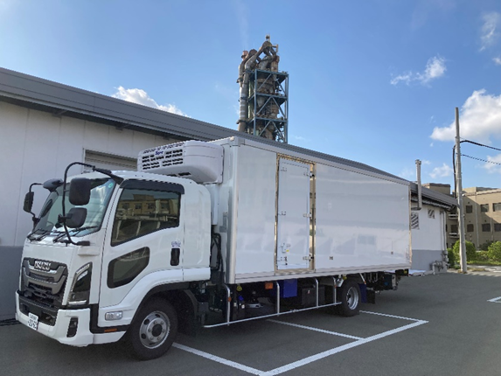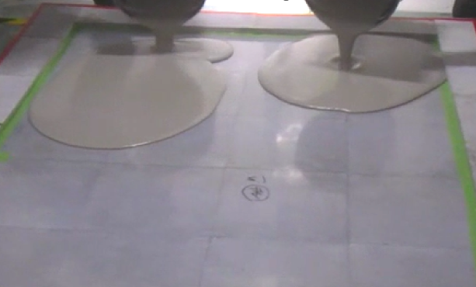
(b)
(a)
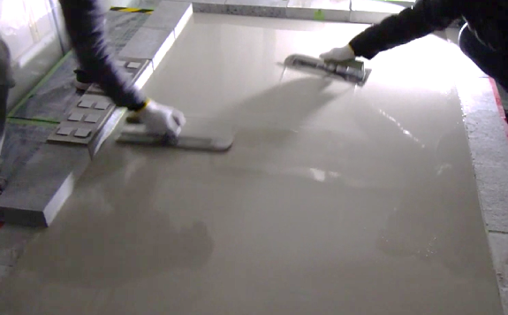 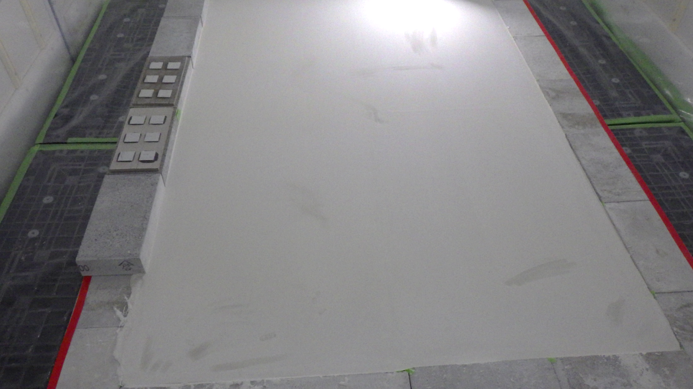
Figure 3. Field application trial inside a refrigerated truck at −25 °C: (a) test environment (refrigerated truck), (b) mortar slurry placement, (c) troweling operation, and (d) finished surface without external heating.
(d)
(c)

Overall, these results underscore the potential application of ACA-based binders for ultra-rapid repair in extreme cold environments. Future studies should address large-area placement strategies and the management of hydration heat in thick sections, as current formulations exhibit very high reactivity that may lead to excessive thermal gradients in massive pours.

REFERENCES
[1] J.J. Petrovic, Review Mechanical properties of ice and snow, J. Mater. Sci. 38 (2003) 1–6, https://doi.org/10.1023/A:1021134128038.
[2] K. Nakagawa, I. Terashima, K. Asaga, M. Daimon, A study of hydration of amorphous calcium aluminate by selective dissolution analysis, Cem. Concr. Res. 20 (1990) 655–661, https://doi.org/10.1016/0008-8846(90)90108-A.
[3] A. Das, J.N. Bousseau, N. Maach, R.J. Flatt, Effect of Temperature on Performance of Calcium Aluminate Cement Based Accelerator, Proc. 16th Int. Congr. Chem. Cement 4 (2023) 26-29, https://doi.org/10.3929/ethz-b-000656329.
[4] A. Franceschini, C. Nalet, P. Taquet, U-Technology, a Specialty Binder – Pushing further the Synchronisation of Ettringite formation, Drymix Mortar Yearbook (2021) 28–37.

