DURABILITY OF CONCRETE CONTAINING ETTRINGITE ACCELERATORS

Benevenuti, Barbara ; Aboulela, Amr ; El Housseini, Sarra
Imerys, 1 Rue le Chatelier, Vaulx-Milieu, France

Keywords: Durability, concrete, accelerator, ettringite, calcium aluminate

ABSTRACT
Previous research^{1,2} has demonstrated the successful use of ettringite-based accelerators to enhance the early-age strength of conventional and low-carbon binders without compromising long-term mechanical properties. The present study investigates their effect on the durability, a crucial factor for their use in concrete, by evaluating key durability indicators including chloride permeability, water porosity, and carbonation, in concrete mixes with and without ettringite-based accelerators.
Results indicate that partial replacement of Portland cement with the accelerator significantly reduced the chloride permeability and had minimal effect on other parameters such as carbonation.
While initial water porosity measurements showed an increase of porosity in accelerated systems, this is likely an artifact which can be attributed to the standard testing method, which involves drying of the concrete at 105°C. At this temperature the ettringite formed during the hydration of the accelerator is partially decomposed, leading to an artificially increased porosity of the cementitious matrix. Alternative testing performed with a 50°C drying temperature revealed significantly lower porosity levels.
These findings suggest that the addition of the ettringite accelerator does not have a deleterious effect on the durability of concrete, despite the expected modifications to the hydrate assemblage, thereby supporting their potential use in concrete applications.

INTRODUCTION | BACKGROUND
Ettringite accelerators (EA), based on a combination of calcium aluminate and calcium sulfate, have been utilized for many years to accelerate the strength development of Portland cement-based mortars^{1,2}, but their application in concrete remains limited. The increasing need to boost productivity in the concrete industry, particularly with the expanded use of supplementary cementitious materials (SCMs)—which often negatively impact early-age strength³—creates an opportunity for using such accelerators. However, this raises the critical question of their impact on long-term durability.
Literature examining the durability of concrete containing EA as an accelerator for Portland-based binders is scarce, with most studies focusing on pure calcium aluminate-based concretes. Nevertheless, some PhD studies have addressed this topic^{4,5,6}. These studies indicate that accelerators composed of ettringite precursors do not compromise durability.
The present study complements this existing data set by evaluating the durability performance of a CEM II-A-based concrete incorporating an ettringite accelerator.

METHODS
Three concrete mixes were tested in this investigation. The reference mix contained 350 kg/m³ of CEM II-A and was designed to satisfy the C40/50 XF1 SF1 Dmax12 criteria. Two derivative accelerated compositions were prepared by replacing 50 kg/m³ and 100 kg/m³ of the CEM II-A with an ettringite accelerator, composed of amorphous calcium aluminate and calcium sulfate.
All concrete compositions maintained an effective water/binder ratio of 0.5, corresponding to 175kg/m3 of water. A polycarboxylate ether (PCE) superplasticizer was included, with the dosage adjusted to ensure comparable consistencies across all mixes. The accelerated systems additionally contained setting regulators.
Compressive strength measurements were performed according to EN 12390-3 and the durability tests were performed following the Performance-Based Approach (PBA) described in the French Technical Report FD P 18-480, which employs durability indicators to ensure a concrete mix is appropriately formulated to achieve its expected service life within a specific operating environment.

KEY FINDINGS
Compressive strengths
The strength results, displayed in Figure 1, show that the EA significantly improves early-age strengths, from 6h to 48h, while having no significant impact on the later-age strengths (7 days and beyond). The magnitude of the early-age strength increase was proportional to the replacement rate of Portland cement with the accelerator.

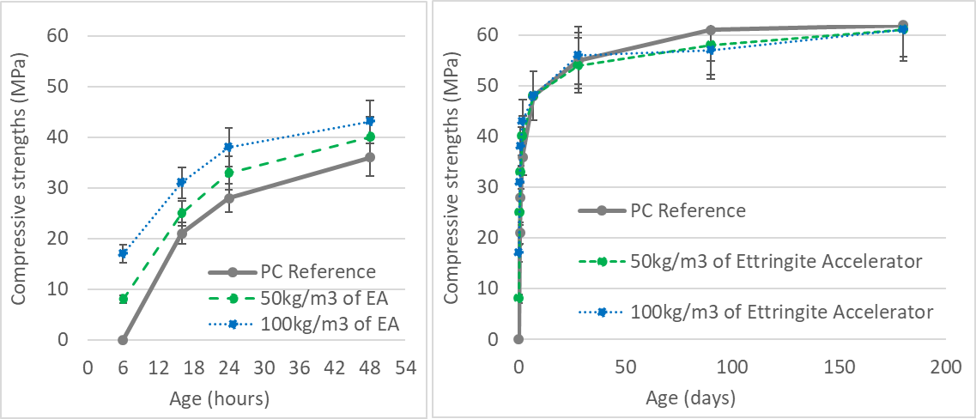
Figure 1: Early (left) and late (right) age strengths of concrete mixes
The fast-forming ettringite generated by the accelerator⁷ contributes to the increase in early-age strengths without preventing the subsequent reaction of Portland cement at later ages and the continued filling of the system's porosity. The observed late-age strengths indicate that the hydrates formed from the accelerator contribute to the densification of the matrix porosity to an extent comparable with the hydrates formed by an equivalent amount of Portland cement.

Durability performance
The durability performance indicators for the three concrete mixes are summarized in Table 1. The results indicate that the partial replacement of Portland cement by the ettringite accelerator does not alter the durability of the concrete.
Regarding electric resistivity and chloride ion diffusion velocity, accelerated systems exhibited superior performance compared to the reference mix, suggesting enhanced resistance to the penetration of deleterious agents. Similar observations have been reported in previous studies⁷, and may be linked to a densification of the hydrate matrix and alterations in its chemical composition, particularly an increase in alumina content, which can favor the formation of Friedel's salt.
Carbonation depths measured across all mixes were extremely low. Quantifiable carbonation was observed only in the system with 100kg/m³ of accelerator, though the extent remained minimal, probably due to the very low porosity of the concrete formulations.
The measured water absorption and porosity to water of the accelerated mixes are superior to the reference. However, this gap is more likely caused by the method of drying the samples than by intrinsic differences between the systems. Ettringite is known to be sensitive to the temperature⁸, and the drying at 105°C, as prescribed by the standard testing procedure, will potentially degrade a portion of the ettringite present in the concrete and generate additional porosity. As the accelerated systems likely contain a higher volume of ettringite, they are expected to present a more pronounced increase in the porosity after the drying at 105°C.
By reducing the drying temperature to 50°C, below dehydration temperature of ettringite, a significant reduction in the measured porosity to water was observed. Unfortunately, a direct comparison of the systems’ intrinsic porosity is not possible, as the reference mix was not dried under 50°C.

Table 1: Durability indicators of concrete mixes
 |  | PC Reference | 50kg/m3 of ettringite accelerator | 100kg/m3 of ettringite accelerator
Electric resistivity @28 days | Ω.m | 58 | 57 |  | 58
Electric resistivity @90 days | Ω.m | 84 | 111 |  | 95
Water absorption @28d (105°C) | % | 5,7 | 6,8 |  | 6,9
Porosity to water @90d (105°C) | % | 9,0 | 15,0 |  | 15,7
Porosity to water @90d (50°C) | % | Not measured | 10,1 |  | 10,4
Chloride ions diffusion @90d | 10⁻¹² m²/s | 8,8 | 6,3 |  | 6,7
Accelerated carbonation coef. @90d | mm/d^{1/2} | 0,00 | 0,00 |  | 0,27

CONCLUSIONS | FUTURE RESEARCH NEEDS
The experimental results for this concrete composition demonstrate that the partial substitution of Portland cement by the ettringite accelerator has a negligible impact on overall durability, despite the expected modification in the proportions of ettringite and calcium-silicate-hydrate (C-S-H) within the formed hydrates, compared to the non-accelerated PC system^{7,9}.
Further investigation is required to quantitatively evaluate the extent of the changes in the hydrate assemblage.
The high drying temperature required by the current testing standards to carry out some of the measurements seems to be not well suited for systems with significant ettringite content. This methodological limitation can lead to an overestimation of water absorption and porosity, which is not reflective of the true durability performance of such systems.
The concrete composition chosen in this study was revealed to be too dense to allow significant carbonation. It would be beneficial to repeat the study with a composition more prone to carbonation in order to better evaluate the impact of the EA.
A relevant topic for future work is the evaluation of the ettringite accelerator effect on the durability of low carbon systems, incorporating SCM, which themselves influence durability performances.

REFERENCES
- J. H. Ideker, K. L. Scrivener, H. Fryda, B. Touzo, 12 - Calcium Aluminate Cements, Editor(s): Peter C. Hewlett, Martin Liska, Lea's Chemistry of Cement and Concrete (Fifth Edition), Butterworth-Heinemann, 2019, Pages 537-584.
- J. Nehring, J. Neubauer, S. Berger, F. Goetz-Neunhoeffer, Acceleration of OPC by CAC in binary and ternary systems: The role of pore solution chemistry, Cement and Concrete Research, Volume 107, 2018, Pages 264-274
- M. Antoni, J. Rossen, F. Martirena, K. Scrivener, Cement substitution by a combination of metakaolin and limestone, Cement and Concrete Research, Volume 42, Issue 12, 2012, Pages 1579-1589
- S. Lamberet, Durability of ternary binders based on Portland cement, Calcium Aluminate Cement and Calcium Sulfate, PhD Thesis, EPFL, 2004.
- E. G. Moffatt, Durability of rapid-set (ettringite-based) concrete, PhD Thesis, University of New Brunswick, 2011.
- R. D. Lute, Durability of calcium-aluminate based binders for rapid repair applications, PhD Thesis, The University of Texas at Austin, 2016.
- S. El Housseini, Hydration and durability of fast hardening binders incorporating supplementary cementitious materials, PhD Thesis, EPFL, 2022.
- H.Y. Ghorab, & U. Ludwig, On the stability of calcium aluminate sulphate hydrates in pure systems and in cements, Proceedings of the 7th International Congress on the Chemistry of Cement, Paris, Vol. IV, pp. 496-503
- S. El Housseini, B. Benevenuti, H. Fryda, M. Chambon, Understanding the strength development of self-compacting concrete formulation incorporating ettringite accelerator as strength booster, Proceedings of the International Conference on Calcium Aluminates, Lausanne, 2026.

