Sustainable Calcium Aluminate Cement Formulations: Partial Clinker Replacement with Activated Chemicals
Polat, Buket¹ , Wolf, Julian^{2,} Avcioğlu, Berrak²

¹ ÇİMSA ÇİMENTO
SANAYİ VE TİCARET A.Ş, TOROSLAR MAH. TEKKE CAD. YENİTAŞKENT – AKDENİZ, Mersin, 33013, TÜRKIYE
²Sabanci Technology Center GmbH, Freisinger Landstraße 50, Garching bei München, 85748, Germany
b.polat@cimsa.com.tr

Reducing the clinker content in calcium aluminate cement (CAC) is crucial for improving environmental sustainability. This study investigates the partial replacement of CAC clinker with activated pumice to optimize setting time and mechanical strength. Experiments were conducted by gradually decreasing the clinker content and replacing it with varying proportions of activated pumice. The hydration kinetics, setting behavior, compressive strength, and microstructural evolution were analyzed.

Results show that, despite a significant reduction in clinker content, early and long-term strength values were maintained when using properly activated pumice. Additionally, the setting time was found to depend on the surface activity and chemical composition of the pumice.

This study demonstrates that clinker substitution in CAC-based systems is feasible, and mechanical performance can be preserved using activated pumice as a supplementary material. The findings provide a foundation for developing low-carbon cement formulations. Future research should explore the effects of different activators and curing conditions.¹

INTRODUCTION | BACKGROUND

The cement industry significantly contributes to global CO₂ emissions due to energy-intensive clinker production. While sustainability efforts have primarily focused on Portland cement, strategies for reducing the environmental impact of calcium aluminate cement (CAC) remain limited. CAC is widely used in refractory applications, rapid repair systems, and chemically resistant environments because of its rapid strength development and high-temperature performance.¹ However, its clinker production requires alumina-rich raw materials and elevated burning temperatures, resulting in considerable environmental impact.

Natural pumice (tras) represents a promising supplementary material due to its high silica content and porous structure, although its reactivity is generally limited without activation. Mechanical activation through fine grinding enhances surface area and exposes reactive silica phases, increasing its potential contribution to hydration reactions.²

Methods

Commercial CAC and mechanically activated pumice were used. Chemical compositions were determined by XRF (Table 1). The Blaine fineness of CAC was 3350 cm²/g, while activated pumice reached 9070 cm²/g after 20 minutes of ball milling. Mortars (4×4×16 cm) were prepared with 5% and 10% clinker replacement at constant water content (28%) and cured at 20°C and 96% RH.

Table 1.Chemical composition of CAC and activated pumice (% by mass)
Oxides | CAC 40 | Activated Pumice
Al₂O₃ | 40.6 | 12.53
SiO₂ | 3.72 | 64.96
CaO | 36.38 | 5.5
Fe₂O₃ | 15.82 | 2.64
MgO | 0.5 | 1.2

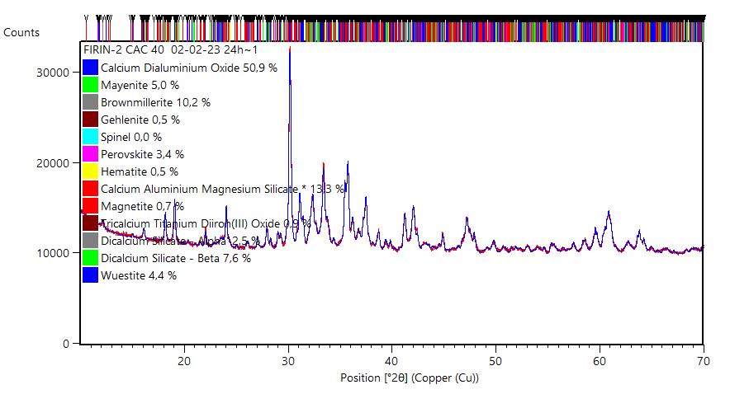

Figure 1. XRD pattern of the CAC clinker

Mechanical Activation
The pumice was mechanically activated using a ball mill for 20 minutes. The activation process aimed to increase the specific surface area. After grinding, particle size distribution analysis indicated a D45 value of 18.85 µm.
Mixture Design
Partial replacement of CAC with activated pumice was performed at different substitution levels. The reference mixture contained 100% CAC, while other mixtures included 5%, 10%replacement of CAC by activated pumice.

Table 2. Mix proportions and replacement levels
Mix ID | CAC (%) | Activated Pumice (%)
Reference | 100 | 0
P5 | 95 | 5
P10 | 90 | 10
* The water content was kept constant at 28%.

Test Methods
Setting time was determined according to the Vicat method. Mechanical and physical tests are done accordingly EN 197-1 to check standard cement sample performance.
Compressive strength tests were performed at 6 hours and 24 hours using a universal testing machine. The performance of pumice-substituted cement was evaluated in self-levelling mortar formulations.

CONCLUSIONS
The setting time and compressive strength results of the reference and pumice-substituted mixtures are summarized in Table 3. The reference CAC mixture exhibited initial and final setting times of 260 and 285 minutes, respectively. In contrast, mixtures incorporating mechanically activated pumice showed a significant acceleration in setting behaviour. The P5 mixture (5% pumice replacement) reached setting times of 150/230
minutes, while the P10 mixture (10% replacement) demonstrated even shorter values of 145/175 minutes. This marked reduction in setting time suggests that finely ground pumice particles enhance early hydration kinetics, likely by increasing nucleation sites and accelerating dissolution processes in alumina-rich systems. Compressive strength results further highlight the beneficial effect of pumice substitution, particularly at early ages. At 6 hours, the reference mixture achieved a strength of 35 MPa, whereas the P5 and P10 mixtures reached
48.8 MPa and 47 MPa, respectively, corresponding to approximately 39% and 34% improvement compared to the reference system. This significant enhancement demonstrates that mechanically activated pumice does not behave merely as an inert filler but actively participates in hydration reactions contributing to early microstructural development.

Table 3. Setting time and compressive strength results of reference and pumice-substituted CAC mixtures

At 24 hours, the reference mixture reached 70 MPa, while the P5 and P10 mixtures achieved 67 MPa and 61 MPa, respectively. Although a moderate reduction in 24-hour strength is observed with increasing pumice content, the values remain within a high-performance range suitable for practical applications.

Table 4. Effect of partial clinker replacement on setting behavior and early-age strength of CAC-based self-levelling underlayment (SLU) formulations
Mix ID | Setting time(min.) | 3h Compressive Strength (MPa) | 6h Compressive Strength (MPa)
REF. | 40/50 | 11.2 | 16.2
P5 | 30/50 | 10.6 | 16
P10 | 35/50 | 11.5 | 15

Mix ID | Pumice Replacement (%) | Setting Time (min.) | 6h Compressive Strength (MPa) | 24h Compressive Strength (MPa)
REF | 0 | 260/285 | 35 | 70
P5 | 5 | 150/230 | 48.8 | 67
P10 | 10 | 145/175 | 47 | 61

The performance of pumice-substituted cement was additionally evaluated in self-levelling mortar formulations. The incorporation of activated pumice allowed a reduction in CAC content within the application recipe while maintaining high early strength and appropriate setting behaviour. Consequently, clinker consumption in the final formulation was reduced, leading to a more sustainable binder design with lower embodied carbon. These findings demonstrate that clinker reduction in CAC systems can be successfully implemented not only at laboratory paste level but also in practical self-levelling applications.

REFERENCES

[1] Bentsen, S. Effect of microsilica on conversion of high alumina cement. In Calcium Aluminate Cements; Chapman and Hall: London,
UK, 1990; p. 294.

[2] 22. Parker, K.M. Refractory calcium aluminate cements. Trans. Br. Ceram. Soc. 1982,82, 35–42

