Comparison of Durability of Calcium Aluminate and Sulphoaluminate Cements (CAC, CSA and HB-CSA) for Aggressive Environment

Binwal*, Bishwjeet, School of Chemical and Biomolecular Engineering, The University of Sydney, Australia; Valix, Marjorie, School of Chemical and Biomolecular Engineering, The University of Sydney, Australia

Keywords: CAC, CSA, HB-CSA, Acid resistance, Alkali-silica reactivity

ABSTRACT
Concrete made with traditional Portland cement in the sewer system is subject to severe corrosion. This leads to deterioration of Portland cement, reducing sewer pipe life and increasing maintenance and repair costs. This research addresses a pertinent issue by evaluating three types of specialty cements: calcium aluminate cement (CAC), calcium sulphoaluminate cement (CSA), and high-belite calcium sulphoaluminate cement (HB-CSA). These materials underwent durability tests under conditions that simulate the environment of sewer systems, utilising laboratory-based methodologies. The findings were unexpectedly significant; in the accelerated corrosion tests conducted in the laboratory, CAC demonstrated superior performance compared to the other types. The results indicate that CAC exhibits enhanced durability in acidic environments, significantly outperforming Portland cement. CAC offers the densest and most chemically inert matrix, making it particularly suitable for the most challenging conditions. In comparison, HB-CSA provides moderate acid resistance. In addition to this test, sorptivity, compressive strength, alkali-silica reactivity (ASR-AMBT), and water absorption were measured. In CAC and HB-CSA, water absorption was around 5%, whereas for CSA, it was slightly higher, around 7%. For sorptivity, all three binder systems were within the <6mm/√h range. Strength development for this study was recorded at 1 and 28 days for mortar and concrete samples.

INTRODUCTION | BACKGROUND
Sewer concrete systems are constantly exposed to biogenic sulfuric acid corrosion, where H₂S generated in the sewer is oxidised to H₂SO₄, leading to rapid acidification. Due to this deterioration of concrete, the global annual maintenance cost is progressively increasing. Corrosion outcomes depend significantly on the testing method and exposure conditions [1,2]. Thus, a reproducible and standardised approach is necessary when comparing binders for server environments. Research indicates that CAC outperforms Ordinary Portland Cement (OPC) in both field and laboratory settings, largely due to its unique hydration chemistry and superior neutralisation capacity [3,4]. However, for CSA and HB-CSA, it has been proposed that these binders can be used as alternatives [5]; however, there is still a need for a direct comparison among all three using a proper test protocol covering fresh, mechanical, and durability properties.

METHODS
The test plan for this study was organised into two stages. The first stage focused on analysing the physical and fresh properties of concrete made with three different binders. It also evaluated their mechanical, durability, and transport properties. In the second stage, the tests primarily assessed these binders under aggressive sewer conditions. To achieve this, a widely used research method was employed: a lab-based testing protocol designed to mimic the effects of concrete exposure to biogenic acids present in the sewer environment, using CAC, CSA, and HB-CSA binders. [2,6,7].

Key Results and CONCLUSIONS

- Fresh properties indicate that concrete made with HB-CSA and CSA sets the fastest, taking less than 30 minutes at a w/c ratio of 0.35. CAC was the only binder that remained workable at a w/c ratio of 0.35. However, at a w/c ratio of 0.3, all binders set within 25-35 minutes.
- CAC and CSA concretes developed a high early strength at Day-1; however, HB-CSA was at 10.1. At Day 28, all three were above 50 Mpa, and CAC was the highest among all (Figure 1).
- None of the three binders showed any expansion when used with reactive sand, and HB-CSA performed best among the three.
- CAC and HB-CSA have lower water absorption than CSA (Table 1). Sorptivity revealed that HB-CSA’s initial and final absorption were lower than those of the other two binders (Figure 2).
- Strength loss during acid immersion for CAC and CSA was similar, ranging from 55% to 58% decrease by 35 days; however, for HB-CSA, it was the lowest, around 41%.
- Mass loss recorded during acid immersion was lowest in CAC, followed by HB-CSA.
- Depth of corrosion indicates that CAC showed the least amount of acid permeation, which was 7.4, followed by HB-CSA at 10.5. However, CSA showed a depth of corrosion of 20.5, even higher than OPC at 13.5 (Figure 3).
Table 1. Water absorption of concrete made CAC, CSA and HB-CSA
Binders | Immersed Absorption; Ai (%) | Boiled Absorption; Ab (%)
CAC | 5.06 ± 0.02 | 5.43 ± 0.01
CSA | 7.19 ± 0.07 | 7.26 ± 0.07
HB-CSA | 5.75 ± 0.07 | 5.78 ± 0.07

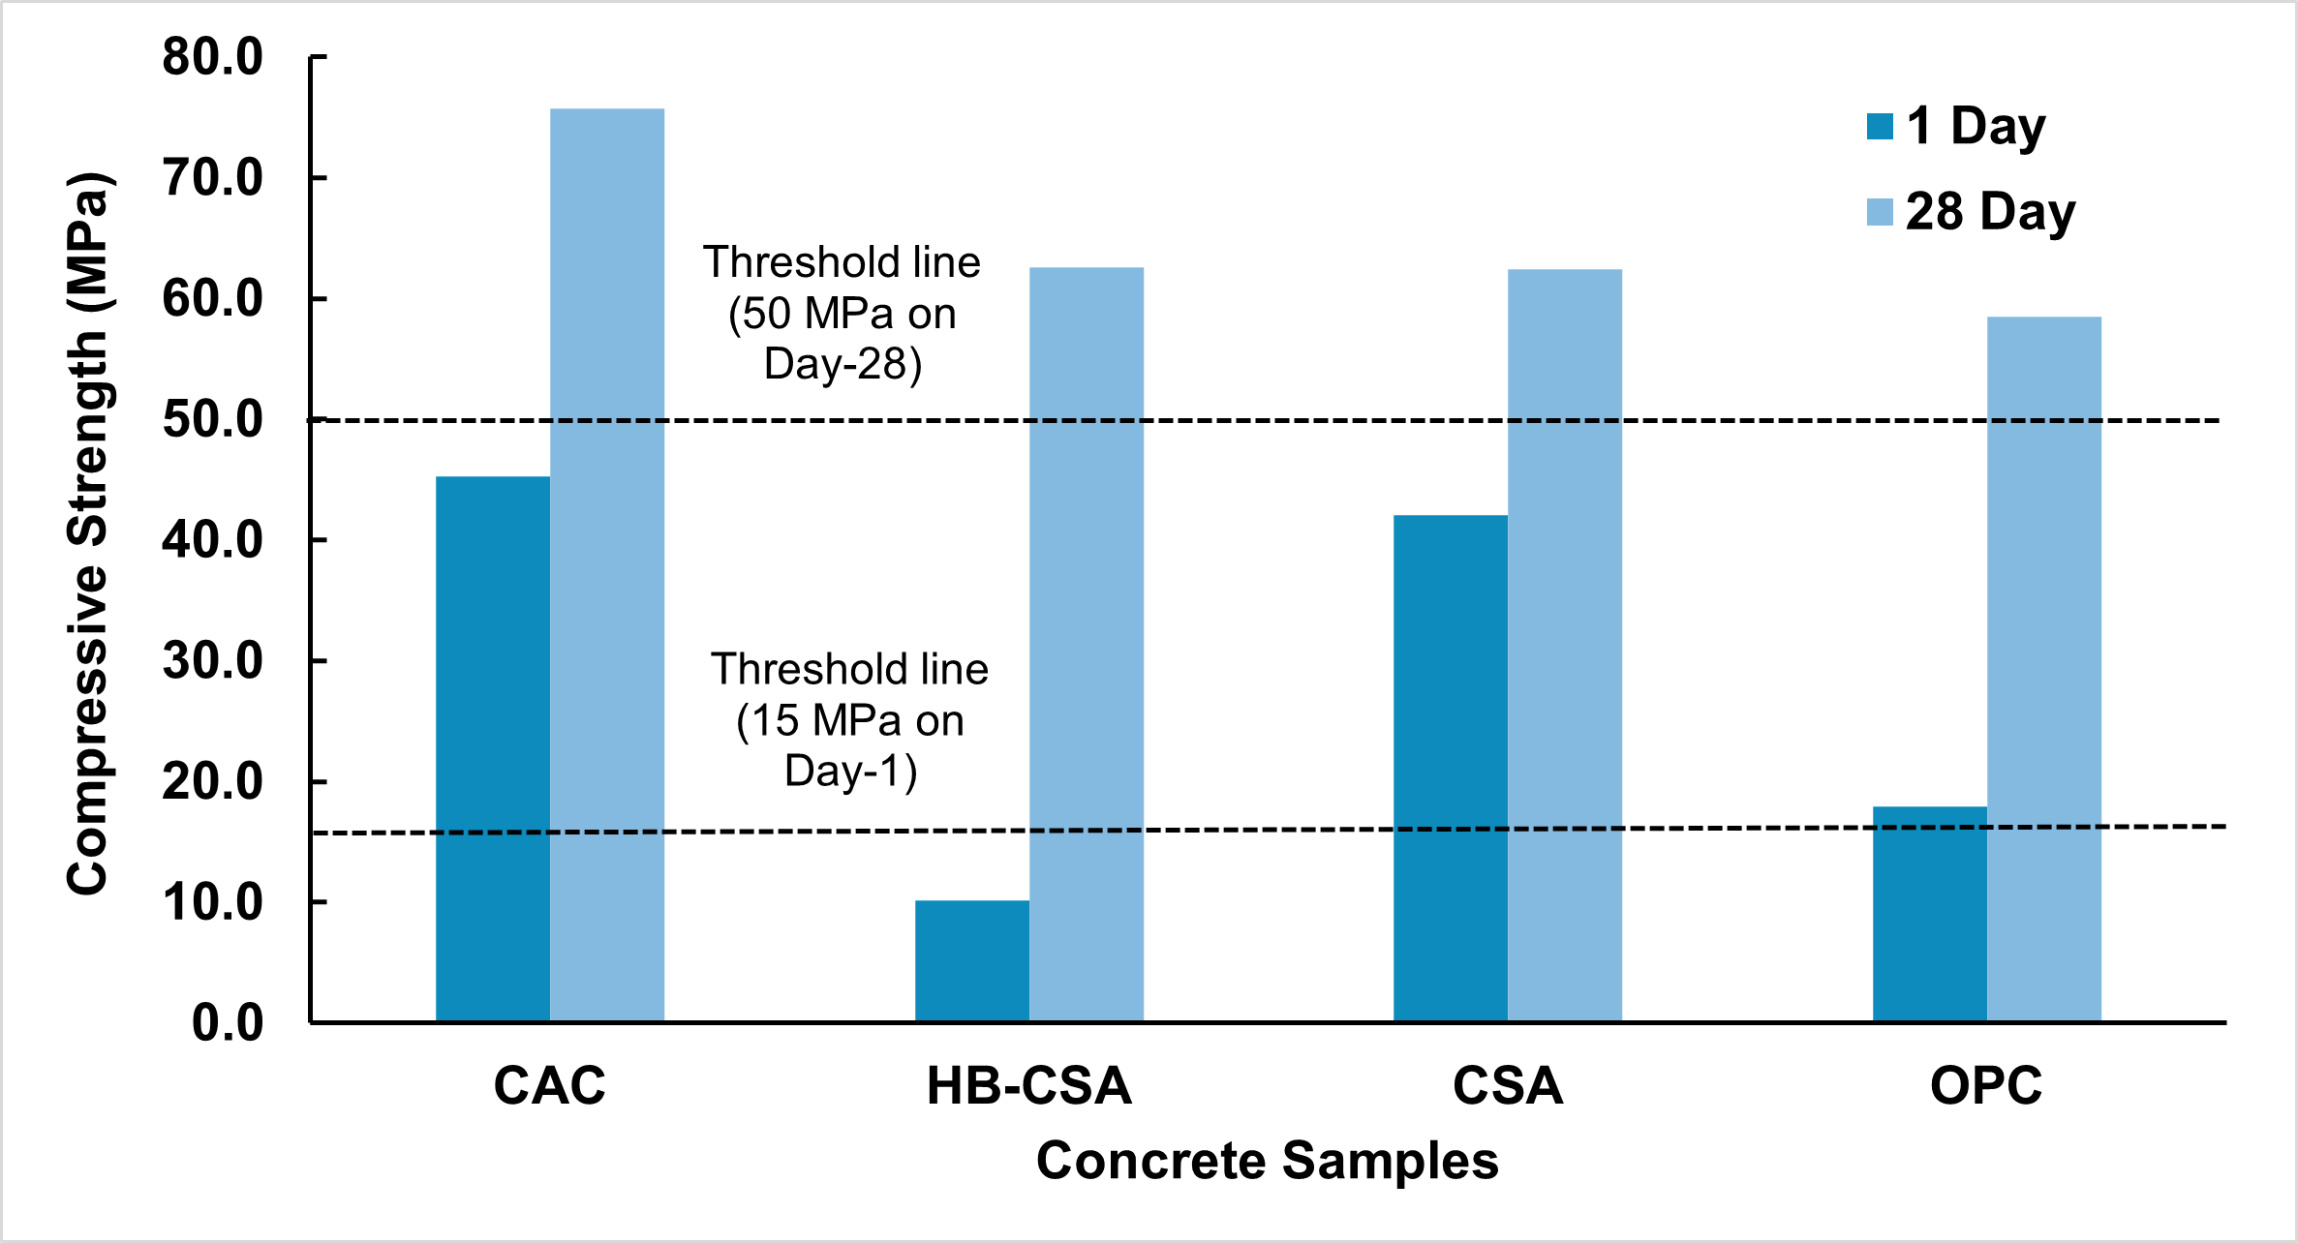
Figure 1. Strength comparison of CAC, CSA and HB-CSA with OPC at Day-1 and Day-28
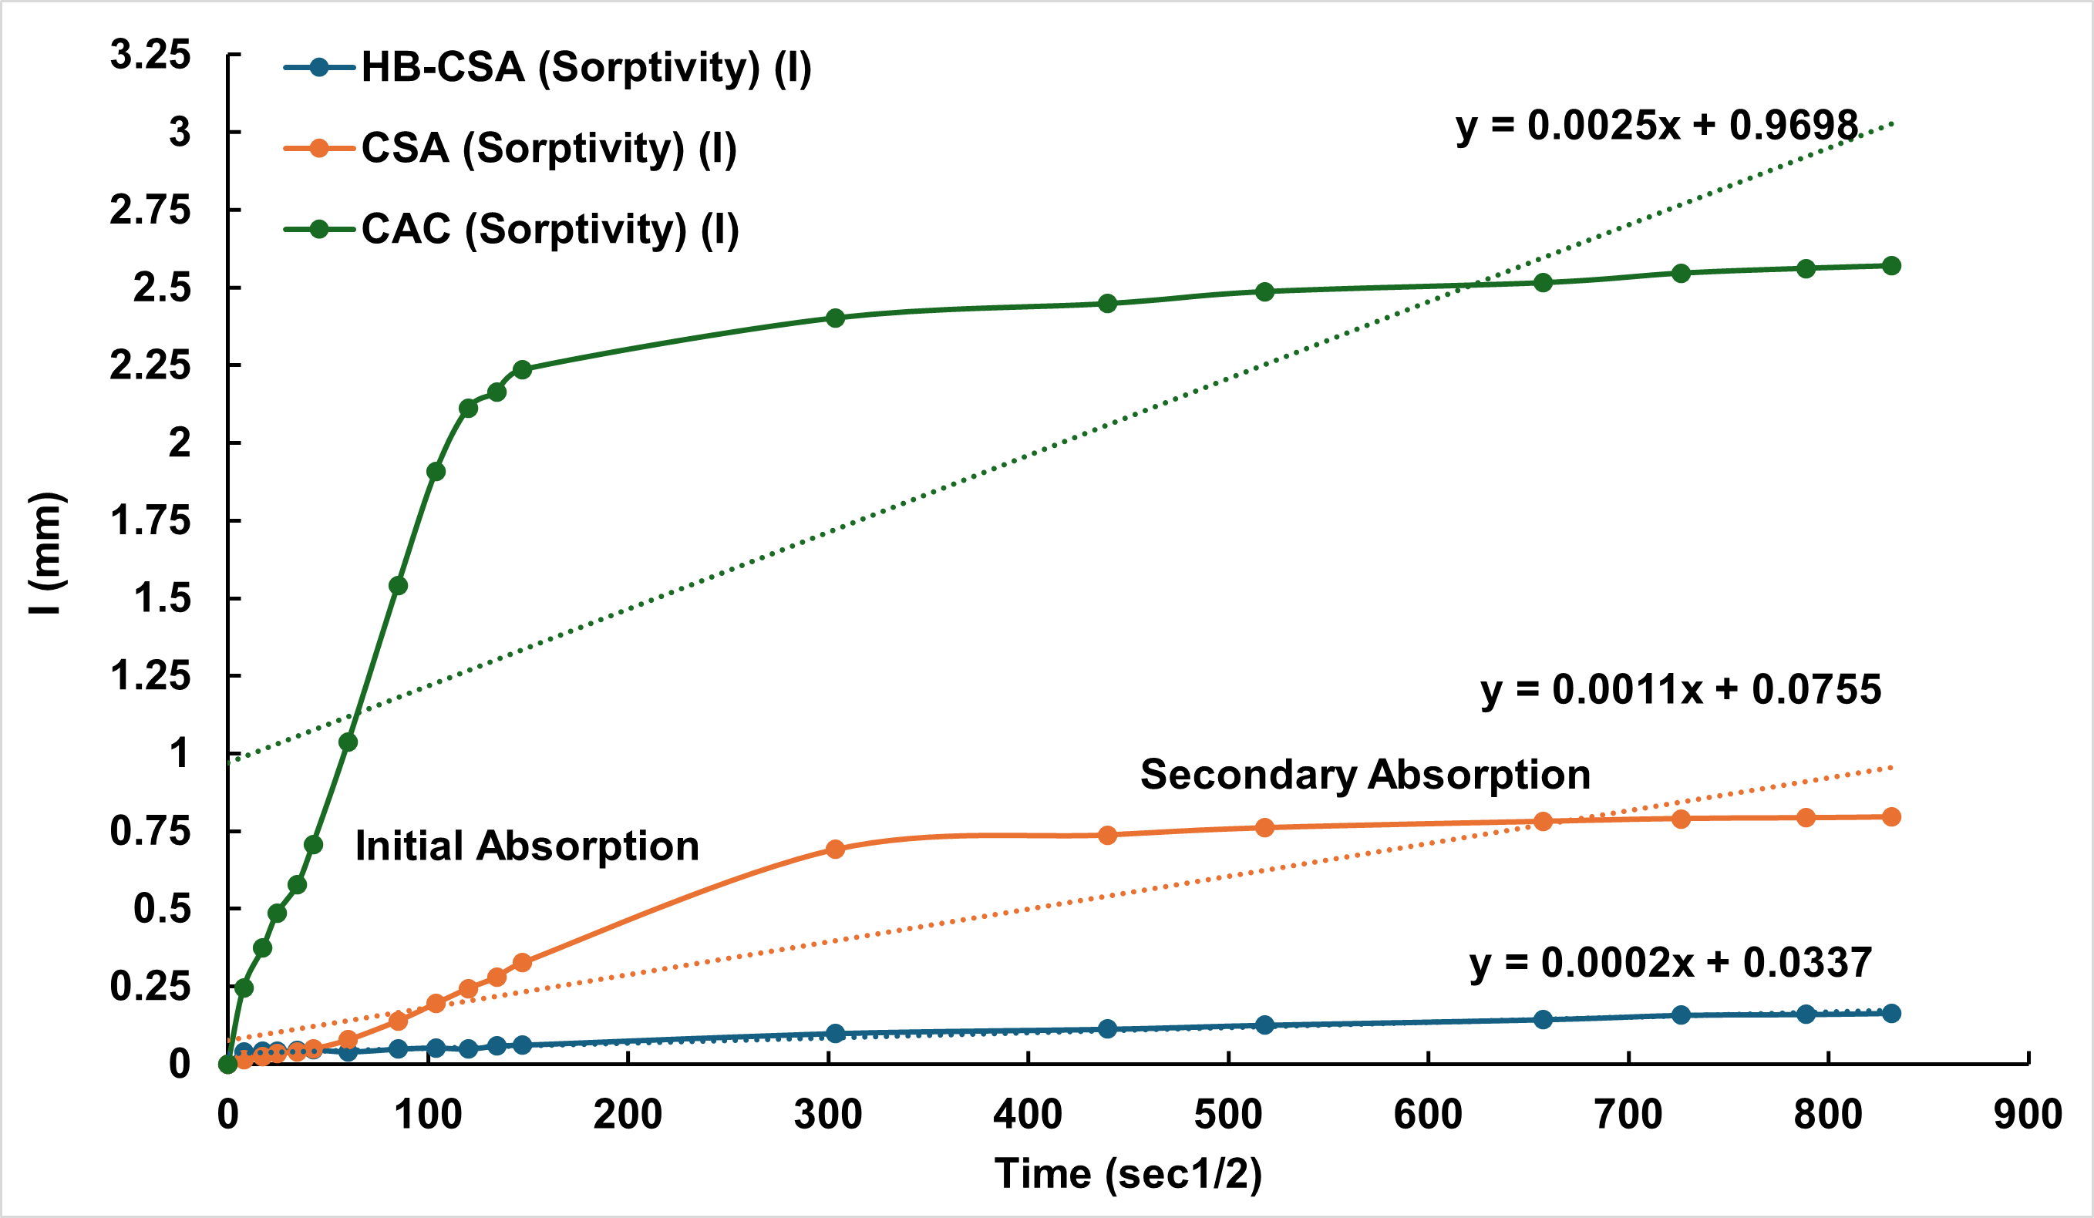
Figure 2. Initial and secondary absorption of CAC, CSA and HB-CSA

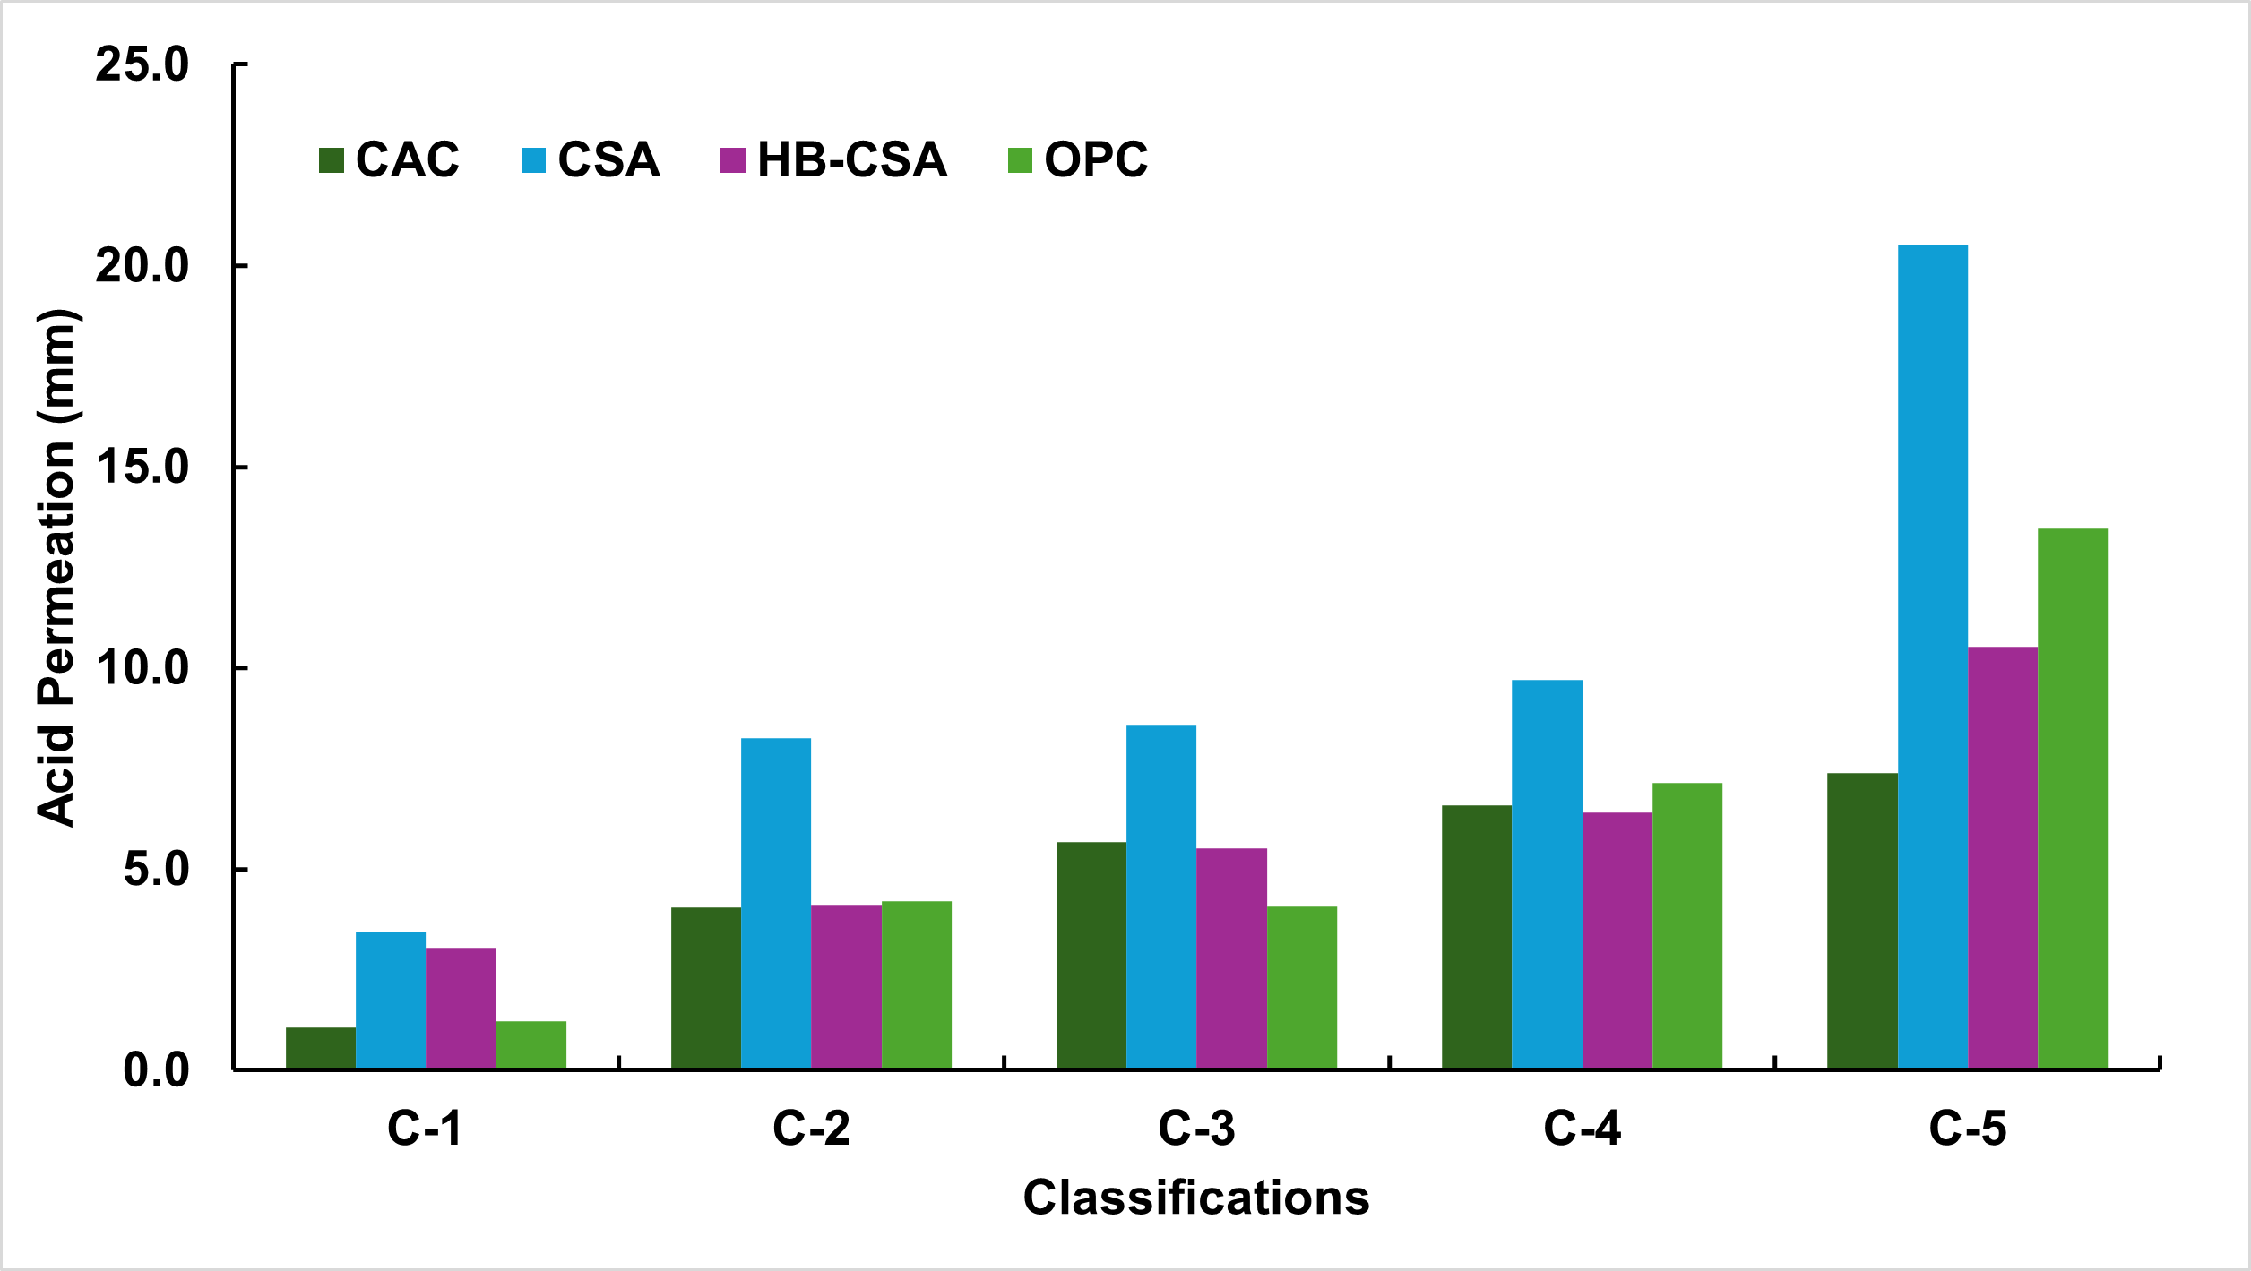
Figure 3. Depth of corrosion of CAC, CSA and HB-CSA at different classifications from C1 to C5 compared with OPC

future research
The experimental program described here is a specific part of a larger thesis framework. In this framework, CAC, CSA, and HB-CSA have been evaluated using standardised protocols to establish a strong performance baseline across key indicators of fresh properties, mechanical properties, and durability. Building on this foundation, the next phase will apply the same testing matrix to newly developed low-carbon binders and directly compare their performance against CAC, CSA, and HB-CSA under the same curing and exposure conditions.

REFERENCES
[1] S.K. Pramanik, M. Bhuiyan, D. Robert, R. Roychand, L. Gao, I. Cole, B.K. Pramanik, Bio-corrosion in concrete sewer systems: Mechanisms and mitigation strategies, Science of The Total Environment 921 (2024) 171231. https://doi.org/10.1016/j.scitotenv.2024.171231.
[2] C. Grengg, F. Mittermayr, N. Ukrainczyk, G. Koraimann, S. Kienesberger, M. Dietzel, Advances in concrete materials for sewer systems affected by microbial-induced concrete corrosion: A review, Water Res. 134 (2018) 341–352. https://doi.org/10.1016/j.watres.2018.01.043.
[3] M.W. Kiliswa, K.L. Scrivener, M.G. Alexander, The corrosion rate and microstructure of Portland cement and calcium aluminate cement-based concrete mixtures in outfall sewers: A comparative study, Cem. Concr. Res. 124 (2019). https://doi.org/10.1016/j.cemconres.2019.105818.
[4] H.A. Khan, A. Castel, M.S.H. Khan, A.H. Mahmood, Durability of calcium aluminate and sulphate resistant Portland cement based mortars in aggressive sewer environment and sulphuric acid, Cem. Concr. Res. 124 (2019). https://doi.org/10.1016/j.cemconres.2019.105852.
[5] A.T. Bakera, A. Aboulela, M.G. Alexander, A. Bertron, M. Peyre Lavigne, S. Meulenyzer, C. Patapy, Performance of Sewer Concretes with Calcium Sulpho-Aluminate Cement and Portland Cement Blends: Field and Laboratory Studies, Materials (Basel). 18 (2025). https://doi.org/10.3390/ma18061256.
[6] P. Sturm, G.J.G. Gluth, C. Jäger, H.J.H. Brouwers, H.C. Kühne, Sulfuric acid resistance of one-part alkali-activated mortars, Cem. Concr. Res. 109 (2018) 54–63. https://doi.org/10.1016/j.cemconres.2018.04.009.
[7] H.A. Khan, M.S.H. Khan, A. Castel, J. Sunarho, Deterioration of alkali-activated mortars exposed to natural aggressive sewer environment, Constr. Build. Mater. 186 (2018) 577–597. https://doi.org/10.1016/j.conbuildmat.2018.07.137.

